WALDEN WOODS
BOARD OF DIRECTORS MEETING MINUTES

MEETING DATE: September 29, 2026

STATUS OF THESE MINUTES: Final

ATTENDANCE:

Directors in Attendance: Pearell, Robertson, Henry, Holcomb, Laliberte, Devlin, Onessimo, Jones, Dostal, Yalamanchili

Directors Absent: Coleman, Bocuzzi

Elite Property Management Representative: Chris Kohnle

- CALL TO ORDER:
Director Russ called the meeting to order at 6:32 PM.

- APPROVAL OF THE PRECEDING MINUTES: Minutes from the September 2, 2026, Board of Director’s Meeting were reviewed and approved. Gordon motioned to approve the Minutes. Louis seconded the motion. Dieter and Beth abstained. The balance of the Board was in favor of approval of the September 2, 2026, Board of Director’s Meeting Minutes.

- UNIT OWNERS’ FORUM – Unit Owners were given the opportunity to address the Board with thoughts and concerns.

- FINANCIAL REPORT: Ken presented the Board with an update on our Reserve Fund as of September 30, 2026, and the Operating Budget status as of August 31, 2026.

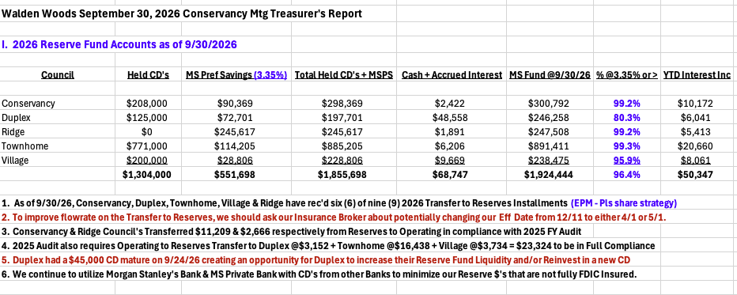
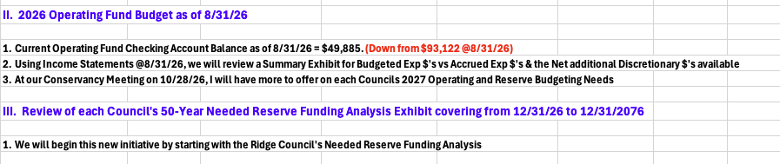

- PROPERTY MANAGER’S REPORT

  - Summary of Property Manager On-site activity:
Property Manager’s Report are on pages 15 and 16 of the BOD Package. The On-Site Activity Reports begin on page 17 of the BOD Package.

  - AAI status:
Six AAIs closed since the last meeting and three new AAIs have been received. There are currently 18 open AAIs.

  - Delinquent fees:
There are three units in Collections as of August 31, 2026. A total of $20,000 is owed to the Association. Of that $20,000, about $4,300 are fines and late fees.

- UNFINISHED BUSINESS:

- CONSERVANCY GOAL
Landscaping & Snow Removal RFQ
Butler submitted a 5-year proposal for consideration. They are adding some additional services and over the course of 5 years the Community will have a savings of $27,560.61.

The proposal does not include seeding the ball field and that cost would be approximately $6,400.

Bill motioned to approve the Updated Proposal based on Attorney approval and Gordon seconded the motion. All were in favor.

Front Sign Replacement
Chris is waiting for a mockup of the new sign. There will be little to no maintenance to this new sign.

Extreme Maintenance will work on the signs at the entrance of Woodmoor next week as a trial. They have been delayed because of the weather.

Reserve Study Update Quotes
This is currently on hold.

Front Entrance Bed
The front entrance garden needs attention with new plantings. Butler submitted a proposal of $7,000. Chris is waiting a proposal from Beebe. This will be a 2027 project.

- MEETING HOUE ACOUSTIC PANELS
Chris met with DDS Acoustical Specialties at the Meeting House for a full evaluation of installing acoustic panels. They submitted a few options with different price points. A “better best” price is $20,000 and a “best” price is $12,000.

It was discussed that an option to slowly install acoustic panels might be considered, but Chris will have DDS Acoustical Specialties come to a Board meeting for specific review of their recommendations.

- 2027 DRAFT BUDGET
The BOD October meeting will be crucial to review the proposed 2027 Budget. Chris will have all the Community numbers by then.

- NEW BUSINESS

- BALL FIELD TENNIS COURT TREE WORK PROPOSAL
Evergreen submitted a proposal for tree work at the upper ball field/tennis. The cost will be $3,450. Gordon motioned to accept Evergreen’s proposal and Louis second the motion. All in favor.

- BUDGET WORKSHOP DATE (OCTOBER 22 OR 26)
Before the next meeting, the Board needs to meet to review the proposed Conservancy Budget. It was agreed to meet on October 26, 2026, at 5:30.

- ANY NEW BUSINESS
Water Issue – Russ handed out a document regarding the water issue with MDC for the Village and Conservancy. He asked the Board to review the document that will be discussed at the October BOD meeting. This issue will be on the Agenda for next month.

Overseeding – It was asked if Butler will be overseeding areas of the Community. Chris said yes.

Tree issues for Conservancy – Trees at the Pool area and pickleball court needs attention. Chris will have it looked at.

- COMMITTEE REPORTS:
Included in BOD Package

- EXECUTIVE SESSION:
None

- NEXT BOARD MEETING:
October 28, 2026, at 6:30 PM.

- ADJOURNED:
Meeting was adjourned at 7:54 pm. Brian motioned to adjourn the Meeting. Gordon seconded the motion. All were in favor.

Respectfully Submitted by,
Regina Sanchez

