WALDEN WOODS
BOARD OF DIRECTORS MEETING MINUTES

MEETING DATE: October 1, 2025

STATUS OF THESE MINUTES: Final

ATTENDANCE:

Directors in Attendance: Moffa, Coleman, Holcomb, Devlin, Dostal, Jones, Laliberte, Henry, Onessimo, Yalamanchili

Directors Absent: Bocuzzi, Robertson

Elite Property Management Representative: Chris Kohnle

- CALL TO ORDER:
Director Russ called the meeting to order at 6:34 PM.

- APPROVAL OF THE PRECEDING MINUTES: Minutes from the August 27, 2025, Board of Director’s Meeting were reviewed with no changes. Fred motioned to approve the Minutes and Gordon seconded the motion. Jennifer abstained from voting. The balance of Board approved the August 27, 2025, Board of Director’s Meeting Minutes.

- FINANCIAL REPORT: Ken reviewed the Financials as of August 31, 2025 with the Board.

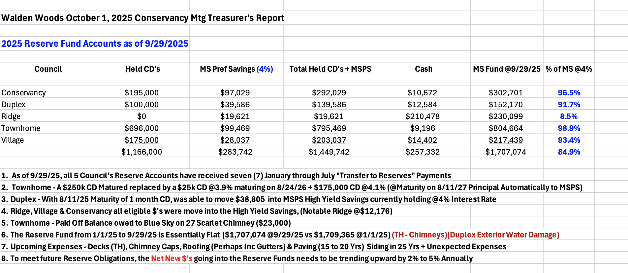

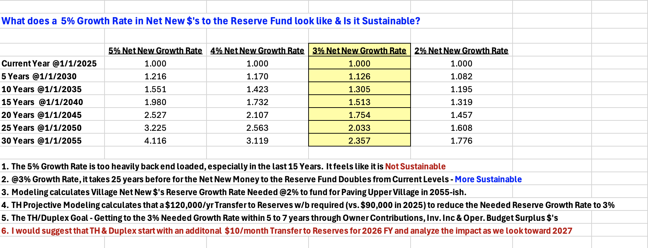

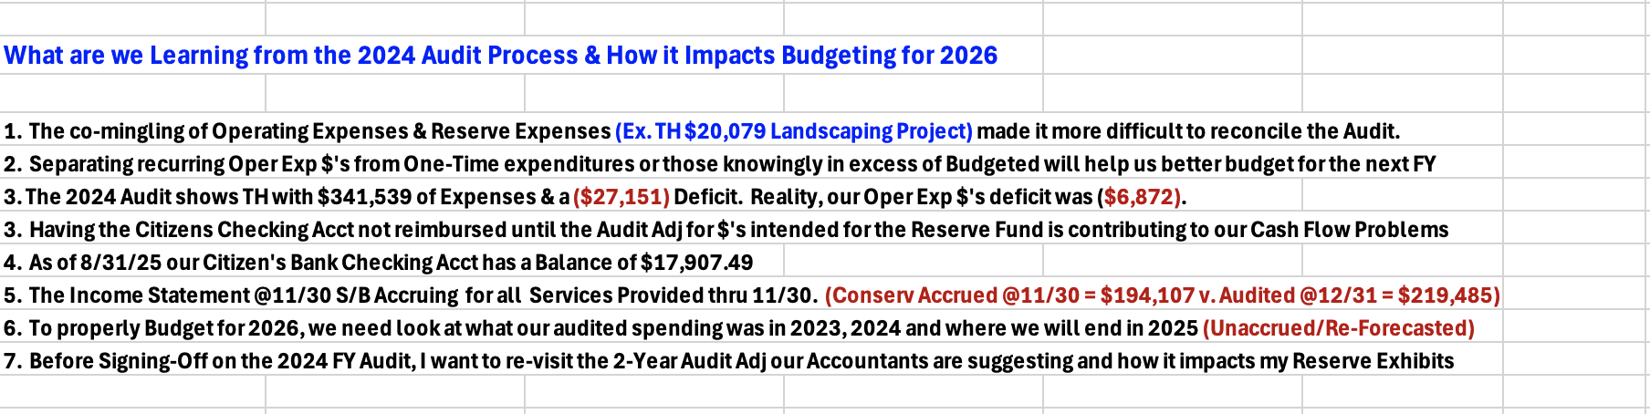

- PROPERTY MANAGER’S REPORT

  - Summary of Property Manager on-site activity:
On-site activity reports start on page 20 of the BOD Package. Manager’s Report is found on pages 18 and 19.

  - Scheduled Pending Services:
Fall clean-up has started as Butler has begun re-seeding several areas and the grass is coming up nicely. The mums are planted, and trees are beginning to be trimmed. The Rhododendrons are still being trimmed, and Chris assured the Board they will all be tended to. Leaves will soon begin to be cleaned up.

  - AAI status:
Eight AAIs have closed since the August 31,2025 meeting. There are five new AAI requests and currently ten AAIs are open.

  - Delinquent fees:
There are three units in Collections and a few more will be added. Seven units make up all the fees owed to the Association. As of August 31, 2025, there is a total of $17K owed to the Association, $7K are fines and late fees.

- UNIT OWNERS’ FORUM – Unit Owners were given the opportunity to address the Board with thoughts and concerns.
- UNFINISHED BUSINESS:

CONSERVANCY GOALS/PROJECTS

Board of Director’s Monthly Minutes
Each month when the prior months BOD Minutes are approved, they immediately get emailed to Chris and Danielle of Elite. The Board approved to add Ann Etre to the email so the Minutes can get posted to the website without delay. The website was behind in uploading the prior Minutes. Ann was not receiving them. Regina is now sending them to Ann directly as well as to Chris and Danielle at Elite.

Meeting House Upgrades
All projects for the Meeting House are completed, and Chris is closing this project(s) from the list.

Benches for Courts
The three new benches for the Courts have been delivered. Chris is closing this project as well. All the benches will be removed for the winter season and stored either in the Cabana or the Meeting House basement.

Court Repairs
Chris and Beth met with Hinding to understand what “new” crackers vs “old cracks” are. Mark from Hinding does not recommend doing any of the repairs now as it should wait until Spring. He will hold the prices for repair of new cracks. The Board should budget about $5,000 each year to make these repairs on “new” cracks as it is a project that will probably need to be done yearly.

It was recommended by Mark that the whole court be repainted to remove the scuff marks. You cannot just paint the areas where the scuff marks are. In some places, they are deep. The cost to repaint is about $6,000 and should be budgeted in the 2026 Budget.

The perpetrator who road their electric scooter on the court has been found. There were witnesses who put it in writing. The perpetrator is pushing back, so Walden Woods Attorney might need to get involved.

Camera for Courts
Horizon Technologies has reviewed the Courts/Pool area regarding cameras and is quoting different options. Relocating a pool camera that is on the pool house cannot be done as there is a tree in the way. There is thought to take one away one camera from the pool area as the pool doesn’t necessarily need 3 cameras. Also, there is consideration for adding a 4th camera to this area that would cover the courts. Horizon is pricing these options out.

Meeting House Patio Repairs
Repairing the Meeting House Patio stones should be considered and budgeted for Spring 2026. It is estimated that $5-6K should be budgeted.

DRAFT AUDIT 2024
This is close to being approved.

DRAFT BUDGETS 2026
A new set of budgets were included in the Board Package. It was recommended that the Board continue to review these budgets. Chris is meeting with different Associations over the next two weeks. Insurance is a huge unknown currently. There could be a 25-30% increase.

A question was asked if the Community could be self-insured. That is not an option.

Chris had dates for the end of October for the Budget workshop. It was decided based on everyone’s availability that November 4th at 6:30 pm will be the scheduled Workshop.

Enumerate Engage has been rolled out. There are still residents that have not completed their accounts, and the Conservancy is behind in receiving September’s Association Fees. Late fees were waived for the month of September, but it was recommended that if payments are not received on time for October that late fees begin to be applied. Chris assured this was happening.

It was asked if this new system would allow the Social Community to send emails directly to the residents about Social events and bypass having Elite manage it. Chris was unsure and recommended that Danielle be contacted. Danielle was contacted but they are still awaiting a reply.

WALKING PATH THOREAU CIRCLE/PIERCE BLVD
The fence on the walking path still has not been replaced. Chris stated it needs to be replaced and should be budgeted for next year.

MEETING HOUSE RENTALS
There was major frustration regarding the processing of the Meeting House rentals and checks submitted for a reservation. Chris met with Pam and worked out the issues. He believes the new Enumerate system will help with this issue as reservations can now be done on-line. Part of the problem was some reservations/checks were submitted via snail mail. Elite did not have a receptionist for a period, so the management of these reservations were not being handled correctly.

- NEW BUSINESS

SOLAR PANEL REQUEST/PROPOSED RULE CHANGE
Because of the new State Statue regarding solar panels/shingles in Communities, the Standards Committee passed the two requests for solar panels to the Conservancy. The law states that Walden Woods cannot restrict the Village, Ridge or Woodmoor from installing solar panels. Duplex and Townhomes are restricted.

Chris stated that Communities have the option to “Opt-Out” but he did not have 100% clarity on its meaning. He has placed a call into the Attorney with a list of questions.

Brian motioned to “Opt Out” of the new law pending review by the Attorney and Ken seconded the Motion. Discussion ensued but this motion did not pass as there were 6 who voted yes and 4 who voted no to the motion.

Gorden then motioned to approve Solar Shingles and “Opt-Out” of the law that required solar panels so the Conservancy can then make our own rules/regulations. This motion would be pending Attorney approval. Fred seconded the motion. Eight voted yes, 2 voted no and Dieter and Ken opposed.

BUDGET WORKSHOP DATE
Date has been set for November 4, 2025, at 6:30 pm

NEW BUSINESS
Meeting House Acoustics
It was recommended that the Meeting House have acoustic panels installed as the sound bounces off the walls and it is difficult to hear. There was a preliminary price of about $1K. Further research should be done, and this issue will be put on the agenda for next month’s BOD meeting.

Dog Park
It was recommended that a dog park be developed in the Community. It is something that can be discussed during the Budget Workshop.

- COMMITTEE REPORTS:
Included in BOD Package

- EXECUTIVE SESSION:
None

- NEXT BOARD MEETING:
October 29, 2025, at 6:30 PM.

- ADJOURNED:
Meeting was adjourned at 8:55 pm. Fred motioned to adjourn the Meeting. Louis seconded the motion. All were in favor.

Respectfully Submitted by,
Regina Sanchez

