WALDEN WOODS
BOARD OF DIRECTORS MEETING MINUTES

MEETING DATE: May 27, 2026

STATUS OF THESE MINUTES: Final

ATTENDANCE:

Directors in Attendance: Bocuzzi, Pearell, Coleman, Holcomb, Onessimo, Devlin, Robertson, Dostal, Jones, Henry, Laliberte,

Directors Absent: Yalamanchili

Elite Property Management Representative: Chris Kohnle

- CALL TO ORDER:
Director John called the meeting to order at 6:32 PM.

- APPROVAL OF THE PRECEDING MINUTES: Minutes from the April 29, 2026, Board of Director’s Meeting were reviewed and approved with a couple changes. John motioned to approve the Minutes, and the Board was in favor of approval of the April 29, 2026, Board of Director’s Meeting Minutes.

- UNIT OWNERS’ FORUM – Unit Owners were given the opportunity to address the Board with thoughts and concerns.

- FINANCIAL REPORT: Ken reviewed the Financials as of April 30, 2026, with the Board.

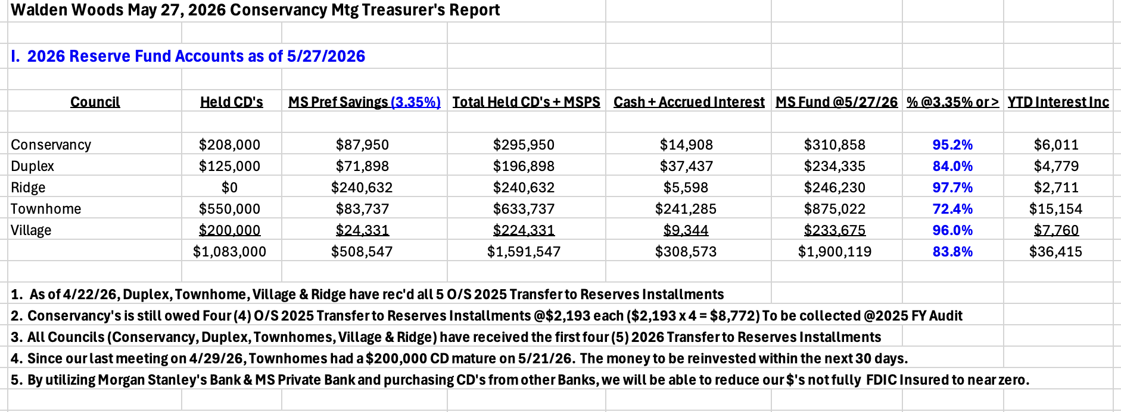

- PROPERTY MANAGER’S REPORT

  - Summary of Property Manager on-site activity:
Property Manager’s Report are on pages 15 & 16 and On-Site Activity Reports begin on page 17 of the BOD Package.

  - Scheduled pending services
There has been a lot of activity in the Community. Much time has been spent at the pool and dropping off Key Fobs to new residents. Chris met with the Health Inspector regarding the pool as well.

It was brought up that the sign on the pool states it is closed. Chris indicated that the pool is open and the gates have been unlocked. Perhaps the sign just needs to be flipped.

  - AAI status:
One AAI closed since the last meeting and four new AAIs has been received. There are currently 19 open AAIs.

  - Delinquent fees:
There are 4 units in Collections as of April 30, 2026. A total of $23,000 is owed to the Association. Of that $23,000, about $4,000 are fines and late fees.

- UNFINISHED BUSINESS:

- CONSERVANCY GOALS
Court Repairs
There was discussion about the cost of repairing/repainting the Courts. It was stated that the cracks need to be repaired as it is hazardous. Safety for everyone is key. On page 21 of the Board Package is an updated quote. The difference in price from the prior quote is for the new cracks. Hinding held their price and will be doing warranty work as well. John motioned to accept Hinding’s proposal. Ken seconded the motion. Dieter voted no and Gordan abstained. The balance of the Board was in favor of approving the moving forward with Court Repairs.

Meeting House Patio Repairs
ND Masonry has scheduled this project for repair from mid to late June of 2026.

Thoreau/Pierce Fence
Fence One has scheduled this repair for June 3, 2026.

Solar Panel Rules
The paperwork is still with the Attorney. He will file the paperwork with the Town to have this process complete. This will stay active until it is 100% finalized.

Landscaping & Snow Removal Contract
RFQs have been sent out to a few companies who can manage this Community. Once their Proposals come in, a decision can be made as to who should be brought in for an interview.

Front Sign Replacement
A quote from Biancha Signs has been requested to replace the Walden Woods sign at the entrance of the Community. The new sign will be composite and never need to be maintained. It will match the current sign with color and design.

It was requested to obtain some new designs. Chris will contact Biancha. The price for a new sign could be from $5 – 7K.

- COMMERCIAL VEHICLE STATUS (Lochview)
The resident on Lochview has until June 8, 2026, to remove his trucks and trailers. He was given another 30 days to remove them. If they are not removed by June 8, 2026, then a hearing will be requested.

- PICKLE BALL COURT DAMAGE
Walden Wood’s Attorney is still working on this issue with the resident.

- NEW BUSINESS
- 8 On the Green Water Bill – Village Request
Russ presented the changes he would like made regarding the water usage bill with the Village and 8 on the Green. Russ motioned to approve his changes. Dieter seconded the motion. A vote was taken. Results are as follows: 4 yes
5 No
John, Beth Abstained

- Meeting House Acoustic Panels
This project was tabled at this meeting.

- Any New Business
Russ requested that the Conservancy split the cost of a water meter on 8 on the Green to measure water usage. It was agreed.

There are two events coming up. One is a Pickel Ball class on June 6, 2026, and the other is a Scavenger Hunt on June 13, 2026.

It was requested that a Reserve Study be brought back up and completed again.

- COMMITTEE REPORTS:
Included in BOD Package

- EXECUTIVE SESSION:
None

- NEXT BOARD MEETING:
June 24, 2026, at 6:30 PM.

- ADJOURNED:
Meeting was adjourned at 8:32pm. John motioned to adjourn the Meeting. Louis `seconded the motion. All were in favor.

Respectfully Submitted by,
Regina Sanchez

