WALDEN WOODS
BOARD OF DIRECTORS MEETING MINUTES

MEETING DATE: March 25, 2026

STATUS OF THESE MINUTES: Final

ATTENDANCE:

Directors in Attendance: Bocuzzi, Coleman, Holcomb, Dostal, Henry, Devlin, Laliberte, Yalamanchili, Onessimo, Pearrell

Directors Absent: Robertson, Jones

Elite Property Management Representative: Chris Kohnle

- CALL TO ORDER:
Director John called the meeting to order at 6:35 PM.

- APPROVAL OF THE PRECEDING MINUTES: Minutes from the February 25, 2026, Board of Director’s Meeting were reviewed and approved. John motioned to approve the Minutes and Louis seconded the motion. All were in favor of approval of the February 25, 2026, Board of Director’s Meeting Minutes. No one opposed.

- FINANCIAL REPORT: Ken reviewed the Financials as of February 28, 2026, with the Board.

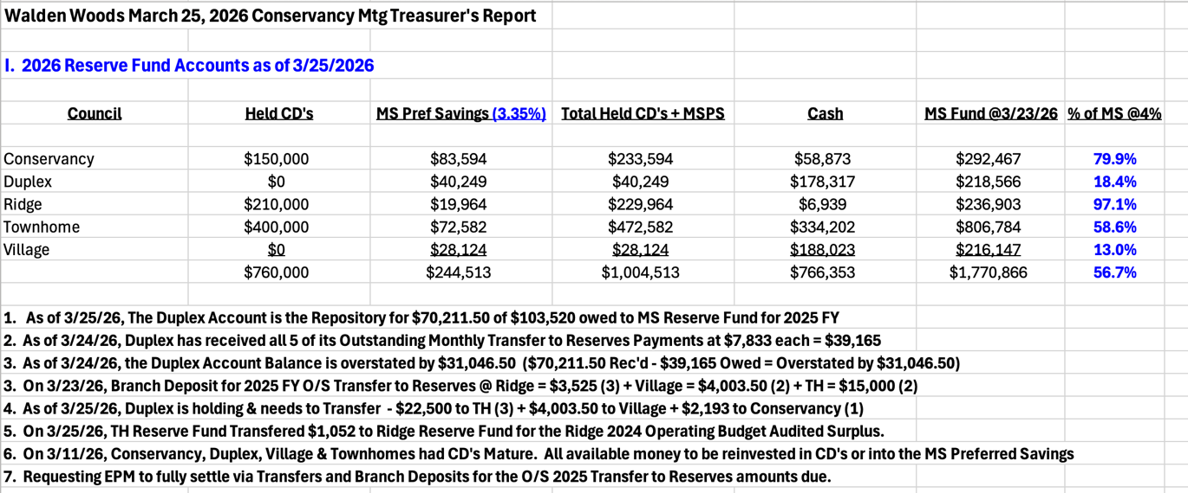

- PROPERTY MANAGER’S REPORT

  - Summary of Property Manager on-site activity:
Property Manager’s Report is on page 16 and on-site activity begins on page 18 of the BOD Package.

  - Scheduled pending services
Snow damage to the Community is being reviewed and repaired and any other alterations to the community from the winter season. Butler is fixing damaged mailboxes as well as damaged cable boxes from the snow.

  - AAI status:
Five AAIs closed since the last meeting and no new AAIs has been received. There are currently 12 open AAIs.

  - Delinquent fees:
There are 6 units in Collections as of February 28, 2026. A total of $31,000 is owed to the Association. Of that $31,000, about $7,000 are fines and late fees.

For those who are past due in their fees, demand letters are continuing to be sent according to the policies in the Bi-Laws.

- UNIT OWNERS’ FORUM – Unit Owners were given the opportunity to address the Board with thoughts and concerns.

- UNFINISHED BUSINESS:
- CONSERVANCY GOALS

Court Repairs
A quote to repaint the courts, repair the warranty issues and any new cracks have been received. The courts will be looked over after the winter season is complete. Chris is having the Tennis Court Company come again and reassess the courts. He will be meeting with them in the next week or two.

Adding Camera or Relocating one for Courts
No action taken at this time.

Meeting House Patio Repairs
Decision has been made to replace the damaged/broken stones. Chris believes the cost was about $3,000 but he will have the price at next month’s BOD Meeting.

Thoreau/Pierce Fence
A large section of this fence is damaged and needs to be fully replaced. Fence-One has looked at it and is submitting a quote. This is a reserve expense for Spring of 2026.

- SOLAR PANEL RULES
The BOD has opted out of the new solar law that was implemented January 1, 2026. The Document was signed by Board members and will be sent to the Attorney who will submit it to the Town. Next step is to create rules for what will be approved for the community in the way of solar.

- COMMERCIAL VEHICLE STATUS
Resident on Lochview returned from Florida on March 9, 2026. The commercial truck on the property was being repaired today. One repair on the truck was done and now another one is being done. Chris will follow up tomorrow.

The resident will remove the commercial truck but is pushing back on the trailer being removed from his property. John will go there to see if they can negotiate the trailer being stored in the back of the house or perhaps behind the fence where Butler stores their equipment.

- LAND SCAPING/SNOW REMOVAL
It is time to review the current specifications for the needs of the Community so that a RFQ can be created and submitted.

Chris recommended the Board go through the Package (starting on page 27 of the BOD Package) to review the Bid Solicitation. This will be discussed at the next Board meeting.

- NEW BUSINESS
- NOTICE AND COMMENT SESSION – PROPOSED SOLAR RULE
Residents submitted their comments regarding the installation of solar panels in the community. Those submissions can be seen starting on page 44. Page 43 has the new language for rules of Solar in the Community.

The Solar Panel rule will stay as it was written last month and will be formally submitted into Walden Woods Rules. John motioned to accept the new solar rule. Beth seconded the motion. All were in favor. No one opposed.

- ANY OTHER NEW BUSINESS
Tag Sale – Participation in the yearly tag sale has fluctuated and it was questioned whether this year should be skipped. John motioned to skip having the Tag Sale this year. Ken seconded the motion. Discussion ensued and a greater number were not in favor. Hence, the tag sale is scheduled for June 27, 2026.

New Board Member for Duplex – The Board welcomed Linda Pearrell to the Board.

Sound Panels for Meeting House – Jennifer will send Chris the proposals for the sound panel installation for the Meeting House.

- COMMITTEE REPORTS:
Included in BOD Package

- EXECUTIVE SESSION:
None

- NEXT BOARD MEETING:
April 29, 2026, at 6:30 PM.

- ADJOURNED:
Meeting was adjourned at 7:57 pm. John motioned to adjourn the Meeting. Brian seconded the motion. All were in favor.

Respectfully Submitted by,
Regina Sanchez

