WALDEN WOODS
BOARD OF DIRECTORS MEETING MINUTES

MEETING DATE: June 24, 2026

STATUS OF THESE MINUTES: Final

ATTENDANCE:

Directors in Attendance: Bocuzzi, Pearell, Holcomb, Robertson, Jones, Dostal, Henry, Laliberte, Coleman, Onessimo, Yalamanchili

Directors Absent: Devlin

Elite Property Management Representative: Chris Kohnle

- CALL TO ORDER:
Director John called the meeting to order at 6:33 PM.

- APPROVAL OF THE PRECEDING MINUTES: Minutes from the May 27, 2026, Board of Director’s Meeting were reviewed with a couple of changes. John motioned to approve the Minutes, and the balance of the Board was in favor of approval of the May 27, 2026, Board of Director’s Meeting Minutes.

- UNIT OWNERS’ FORUM – Unit Owners were given the opportunity to address the Board with thoughts and concerns.

- FINANCIAL REPORT: Ken provided the Board with an update on our Reserve Fund as of June 22, 2026, and the Operating Budget status as of May 31,2026

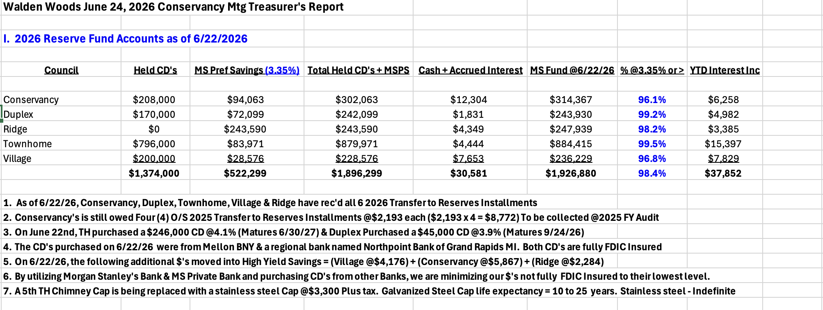
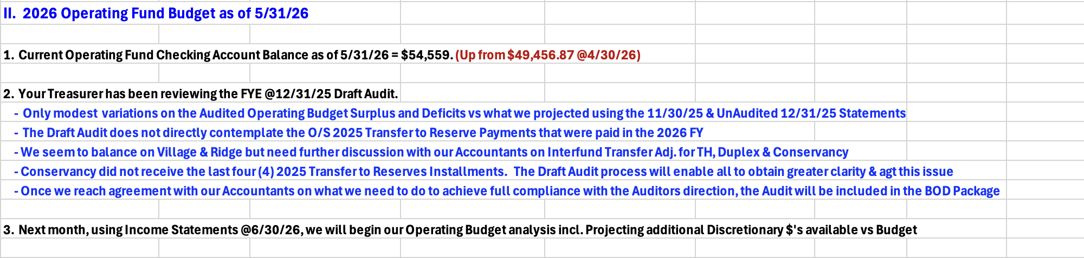

- PROPERTY MANAGER’S REPORT

  - Summary of Property Manager on-site activity:
Property Manager’s Report is on pages 15 and 16 of the BOD Package and the On-Site Activity Reports begin on page 17 of the BOD Package.

  - Scheduled pending services
Much activity happening in the Community this time of year. Meetings with contractors, following up on AAIs, Pool issues etc.

  - AAI status:
Four AAI closed since the last meeting and one new AAI has been received. There are currently 17 open AAIs.

  - Delinquent fees:
There are 3 units in Collections as of May 31, 2026. A total of $21,000 is owed to the Association. Of that $21,000, about $3,400 are fines and late fees.

- UNFINISHED BUSINESS:

- CONSERVANCY GOAL

Court Repairs - Hinding Tennis has been approved to move forward with repairs and warranty work. It is scheduled, tentatively, for July 15, 2026. As we get closer to that date, Chris will confirm the exact date. The courts will be closed for 4-5 days while the repairs are going on.

Adding Cameras or Relocating One – Two signs and 2 cameras were ordered to place one set at the Tennis Courts and one set at the Pickleball Courts.

Meeting House Patio Repairs – ND Masonry was scheduled for this week but because of the rain it is scheduled for the week of the June 29th 2026.

Thoreau/Pierce Fence – Fence One was delayed and re-scheduled for this week. It hasn’t been confirmed if it was complete because of the rain this week. Chris will keep on eye on this project.

Landscaping and Snow Removal Contract – RFQs have been sent out to 6 companies. Bill’s Landscaping has declined to submit a proposal. EA Quinn will submit a proposal as well as Beebe, Butler, DW Burr and Brightview. Irrigation in the RFQs have been segmented separately.
It was requested that the Board contact Anderson Irrigation in Avon to submit a proposal for the community. They handle town work. Chris will contact them.

Front Sign Replacement – Biancha Signs is still working on a quote for a new sign at the entrance of Walden Woods. It was recommended that something be done with the entry signs on the stone walls. They are no longer visible and it was recommended that Chris ask Biancha if they can do something to clean them up.

Reserve Study Update – Reserve Advisors provided a proposal of $9,850 to do a Reserve Study. A Level One study was done in 2016/2017 so a new study needs to be completed. Still awaiting on an update from Becht Engineering.

- COMMERCIAL VEHICLE STATUS (LOCHVIEW)

John, Gordon and Chris met with the resident. The resident purchased property from the town that runs alongside his property and now parks his truck and trailer there. The resident also had a list of what he wants the Board to do regarding several issues. The list was passed to each Board member for their review and discussion will ensue at next Board meeting.

- PICKLE BALL COURT DAMAGE

Will be discussed in Executive Session

- SOLAR PANEL OPT OUT RE-VOTE

There was a slight technical issue with paperwork and the voting to Opt-Out. A new Vote needs to be presented. John Bocuzzi motioned to Opt-Out of new CT State Law. Bill Robertson seconded the motion. The following Board Members were in favor: Linda Pearell, Jennifer Coleman, Beth Holcomb, Brian Onessimo, Dieter Dostal, Gordon Jones, Rao Yalamanchili, Louis Henry and Ken Laliberte.

- NEW BUSINESS

MEETING HOUSE ACOUSTIC PANEL

On page 21 of the Board Package is information of different Acoustic Panel options. It was requested that Jennifer get samples of colors with cost. Also confirm if they are fire rated (NFPA Rating).

NEW BUSINESS TO DISCUSS
Butler has been trimming trees, and all is going well. There are trees hanging over walkways. They will be taken care of.

The lights that are on Walden Meadow and Pierce are still out. Gordon has called the Town but not having much success. John will write a letter to the Department of Public Works to get these lights replaced.

Meeting House alarm is not always reset after someone utilizes the Meeting House. It was discussed that it is difficult to turn the alarm back on. Chris will investigate having the Alarm company automatically reset it. It was questioned if the codes on the Alarm also be changed periodically since there are multiple people who have it. There has never been a problem so all should be ok.

Jennifer would like to know how many residents are on Enumerate because there are people not getting messages. Chris will have Danielle send a list to Jennifer. It was recommended that instructions be sent out to show people how to add additional family members.

Parking at the Meeting house should be ok for a short period but they shouldn’t be staying overnight. Towing laws have changed and cars need to be tagged first before proceeding with having them towed.

There is a family friendly Pool event this Friday, June 26th from 5 – 7 pm

- COMMITTEE REPORTS:
Included in BOD Package

- EXECUTIVE SESSION:
Meeting to discuss Pickleball damage.

- NEXT BOARD MEETING:
July 29, 2026, at 6:30 PM.

- ADJOURNED:
Meeting was adjourned at 7:56pm. John motioned to adjourn the Meeting. Gordon seconded the motion. All were in favor.

Executive Session was called to order at 7:56 pm. and adjourned at 8:28 pm.

Respectfully Submitted by,
Regina Sanchez

