WALDEN WOODS
BOARD OF DIRECTORS MEETING MINUTES

MEETING DATE: July 29, 2026

STATUS OF THESE MINUTES: Final

ATTENDANCE:

Directors in Attendance: Bocuzzi, Pearell, Holcomb, Onessimo, Devlin, Robertson, Jones, Laliberte, Yalamanchili, Henry

Directors Absent: Coleman, Dostal

Elite Property Management Representative: Chris Kohnle

- CALL TO ORDER:
Director John called the meeting to order at 6:34 PM.

- APPROVAL OF THE PRECEDING MINUTES: Minutes from the June 24, 2026, Board of Director’s Meeting were reviewed with one change. John motioned to approve the Minutes. Ken seconded the motion and the balance of the Board was in favor of approval of the June 24, 2026, Board of Director’s Meeting Minutes.

- UNIT OWNERS’ FORUM – Unit Owners were given the opportunity to address the Board with thoughts and concerns.

- FINANCIAL REPORT: Ken presented the Board with an update on our Reserve Fund as of July 27, 2026, and the Operating Budget status as of June 30, 2026.

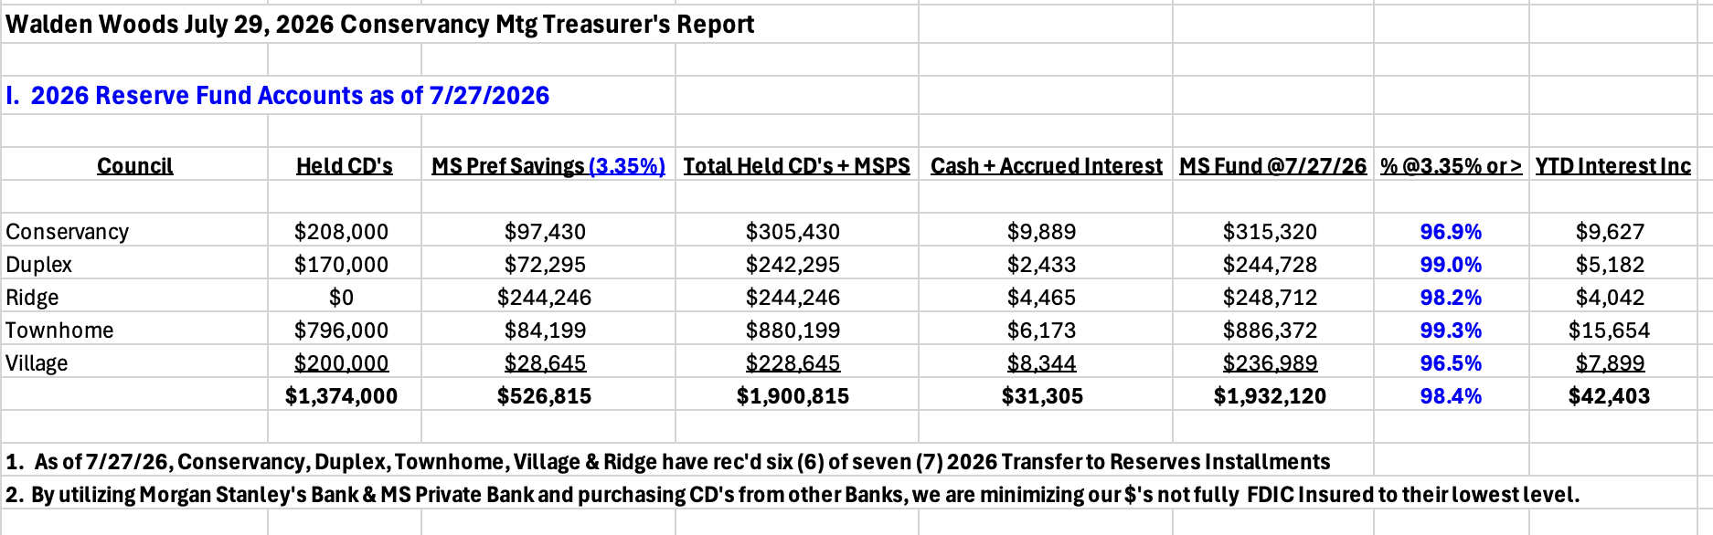
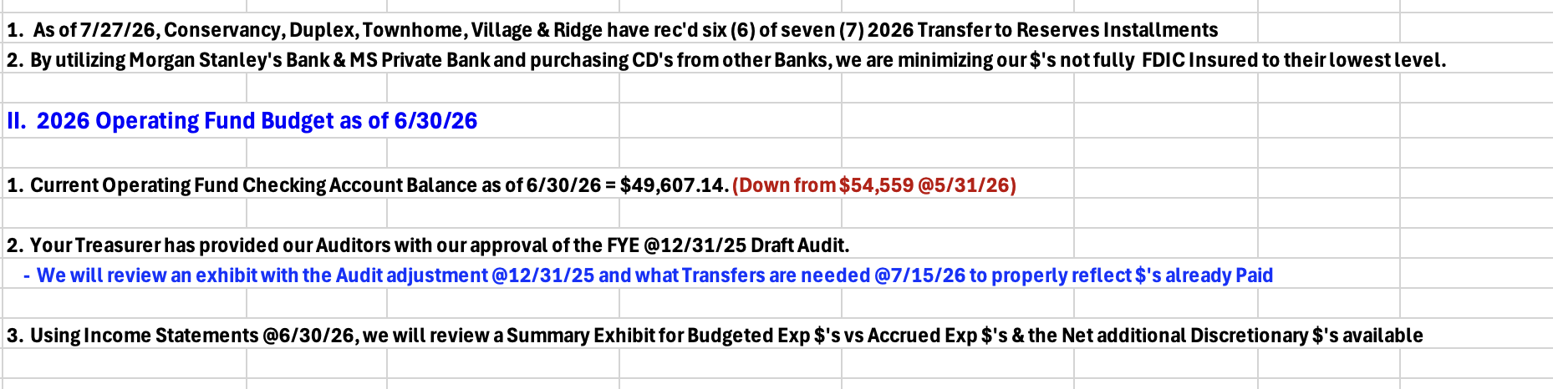

- PROPERTY MANAGER’S REPORT

  - Summary of Property Manager On-site activity:
Property Manager’s Report is on pages 15 and 16 of the BOD Package and the On-Site Activity Reports begin on page 17 of the BOD Package.

  - Scheduled pending services
This month included maintenance throughout the community, work on Scarlet Lane, receiving RFQs for landscaping and snow removal, meeting with contractors and pool work.

  - AAI status:
Seven AAIs closed since the last meeting and three new AAIs have been received. There are currently fourteen open AAIs.

  - Delinquent fees:
There are three units in Collections as of June 30, 2026. A total of $22,000 is owed to the Association. Of that $22,000, about $3,500 are fines and late fees.

- UNFINISHED BUSINESS:

- CONSERVANCY GOAL
Court Repairs
Repairs to the courts have begun and should be completed in about a week, weather permitting. The Pickleball Court has been completed. Warranty work on the Tennis Court still needs to be finished (about 15 feet of the court).

Adding Cameras to Courts
Camera and signs have been installed on both courts.

Meeting House Patio Repairs
ND Masonry has completed the patio repairs, and it came out great.

Thoreau/Pierce Fence Repairs
Fence One has made the repair to the fence on Thoreau/Pierce. Next step is to clean the full fence. Marco will be attending to this soon.
Solar Panel Rules
According to WW Attorney, the paperwork was correct and has been filed with the Town to record in the land records. As soon as the executed copy is received from the Town, this issue will be closed.

Landscaping/Snow Removal RFQ
Six RFQs have been sent to companies for pricing. Four Landscape companies have responded. Two companies declined to bid. The Four Landscape companies’ Proposals are included in the BOD Package.

Discussion ensued about extending the Contract from 3 years to 5 years to obtain a lower price than currently received. Patrick from Butler will attend the next meeting to discuss this option.

Anderson Irrigation was contacted to submit a proposal for just irrigation but declined. They only manage systems they install. They do not manage old systems.

Discussion ensued also about fixing the area where Butler stores their trucks in the winter to make it look more appealing. Chris will contact Butler about that.

Front Sign Replacement
Bianca Signs is still working on new designs, and it should be available by next meeting. They will also quote a price for cleaning the 9 pillar signs.

In the Board Packet (page 25) is a quote from Extreme Maintenance to clean and polish the 9 pillar signs. It was requested for them to do one sign to see the results of the cleaning and polishing.

Reserve Study Update Quotes
In 2020, the last Reserve Study was completed. In the BOD Package, are two quotes. One from Reserve Advisors - $9850 and the other from Becht Engineering - $6200. It is recommended to do one every three years.

- PICKLE BALL COURT DAMAGE

Will be discussed in Executive Session.

- NEW BUSINESS

- Meeting House Acoustic Panel
On page 27 of the BOD Package, is a description of Acoustic Panels. They are fire rated. It was recommended that some research be done to have someone come and do an analysis of the Meeting House to determine where panels should be placed and how many panels would be needed. Chris will investigate.

- 2025 Draft Audit Review (During Treasurer’s Report)
Audit has been completed.

- Landscaping/Snow Removal RFQ Proposals
Six RFQs have been sent to companies for pricing. Four Landscape companies have responded. Two companies declined to bid. The Four Landscape companies’ Proposals are included in the BOD Package.

Discussion ensued about extending the Contract from 3 years to 5 years to obtain a lower price than currently received. Patrick from Butler will attend the next meeting to discuss this option.

Anderson Irrigation was contacted to submit a proposal for just irrigation but declined. They only manage systems they install. They do not manage old systems.

Discussion ensued also about fixing the area where Butler stores their trucks in the winter to make it look more appealing. Chris will contact Butler about that.

- 2027 Draft Budget Discussion
A draft of the 2027 Budget has been sent to each BOD Member. Chris recommended everyone to review and submit changes.

- August Meeting Date Request To Move To September 2nd
It was asked that the August BOD Meeting be moved to September 2nd as Chris will be out of town. Everyone was in favor.

- Any New Business?

Tennis Court
Chris is waiting for a proposal to have the evergreens trimmed around the Tennis Court. It should also be considered to have the Court cleaned next year.

Lights on Walden Meadows
John will contact the Public Works department to have them come and fix the light posts that have been out for a while.

- COMMITTEE REPORTS:
Included in BOD Package

- EXECUTIVE SESSION:
Meeting to discuss Pickleball damage.

- NEXT BOARD MEETING:
September 2, 2026, at 6:30 PM.

- ADJOURNED:
Meeting was adjourned at 7:52 pm. Bill motioned to adjourn the Meeting. Russ seconded the motion. All were in favor.

Executive Session was called to order at 7:52 pm. and adjourned at 7:58 pm.

Respectfully Submitted by,
Regina Sanchez

