WALDEN WOODS
BOARD OF DIRECTORS MEETING MINUTES

MEETING DATE: February 25, 2026

STATUS OF THESE MINUTES: Final

ATTENDANCE:

Directors in Attendance: Bocuzzi, Coleman, Holcomb, Dostal, Henry, Jones, Laliberte,

Directors Absent: Robertson, Yalamanchili, Onessimo, Devlin

Elite Property Management Representative: Chris Kohnle

- CALL TO ORDER:
Director John called the meeting to order at 6:33 PM.

- APPROVAL OF THE PRECEDING MINUTES: Minutes from the February 4, 2026, Board of Director’s Meeting were reviewed with one clerical change. John motioned to approve the Minutes and Louis seconded the motion. All were in favor of approval of the February 4, 2026, Board of Director’s Meeting Minutes. No one opposed.

- FINANCIAL REPORT: Ken reviewed the Financials as of January 31, 2026, with the Board.

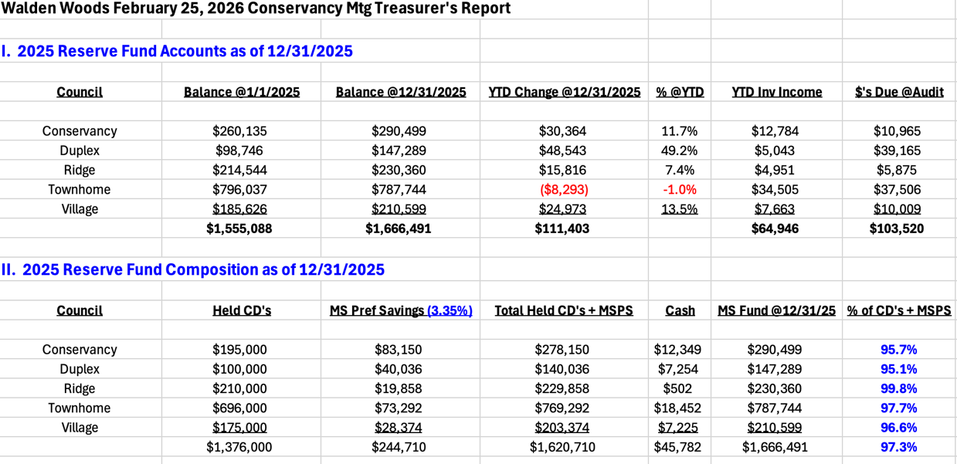

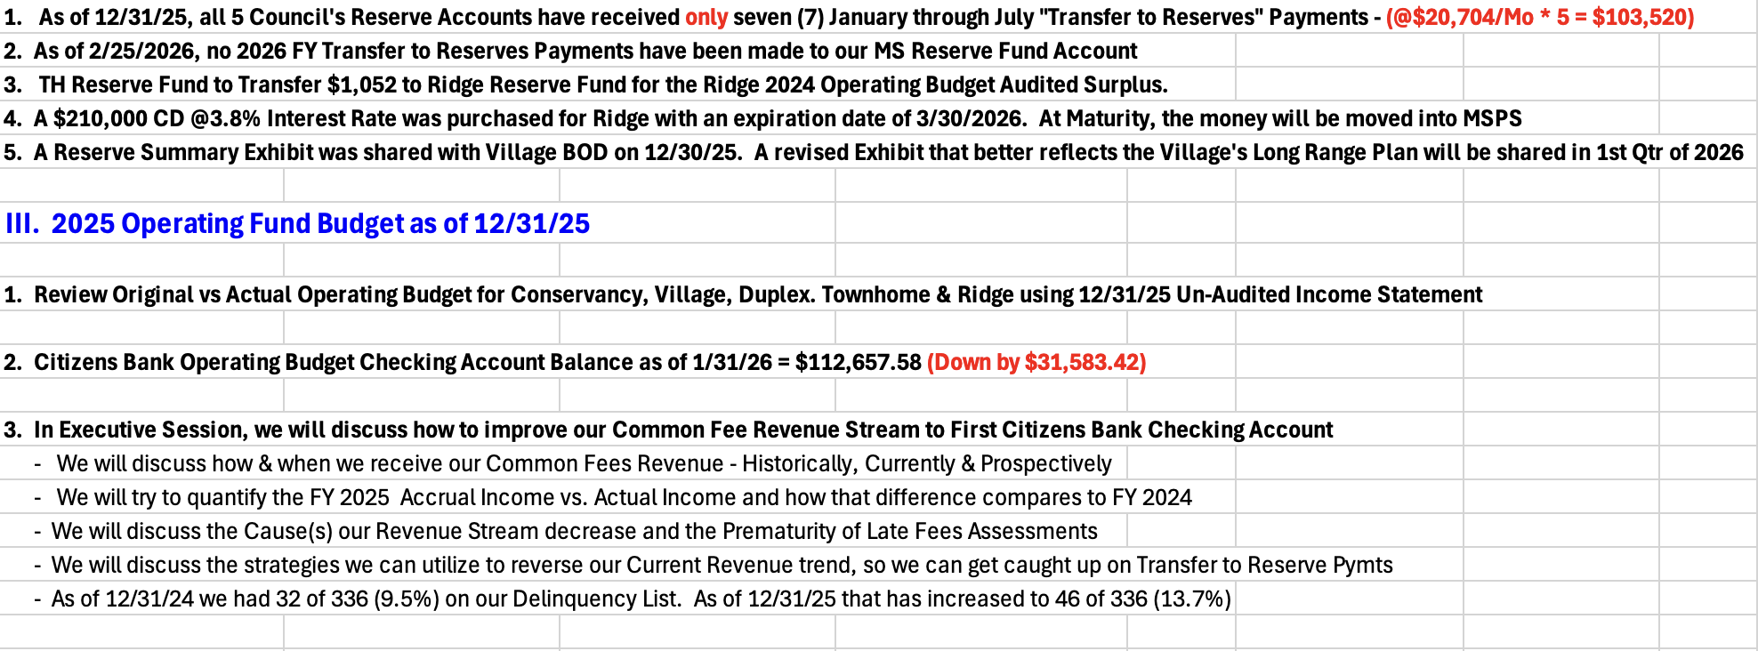

- PROPERTY MANAGER’S REPORT

  - Summary of Property Manager on-site activity:
Property Manager’s Report is on page 14 of the BOD Package.

Snow continues to be the biggest focus right now. Ice dams are not forming in Townhomes, Duplex or Village and most leaks have stopped.

A window cornice from 7 Last Leaf Circle has blown off. It is not damaged and just needs to be touched up with paint and then reinstalled. Chris will write up a work order to have it put back in place.

A question was raised about salting driveways. Chris stated that Butler will apply salt after a storm but there is no way they can keep up with the melting and refreezing. If a resident is concerned and has ice in their driveway/sidewalk, they should purchase some salt and apply it.

  - AAI status:
One AAI closed since the last meeting. One new AAI has been received and currently there are 15 open AAIs.

  - Delinquent fees:
There are 6 units in Collections. As of January 31, 2026, there is a total of $33,000 owed to the Association. Of that $33,000, about $7,000 are fines and late fees.

Chris was directed to waive late fees of residents who are now current with their Association fees since the new Enumerate Engage System was installed. He is to waive their fees even if it took a few months for them to get current.

- UNIT OWNERS’ FORUM – Unit Owners were given the opportunity to address the Board with thoughts and concerns.

- UNFINISHED BUSINESS:
- CONSERVANCY GOALS
Court Repairs – A quote was received to repaint the courts, do the warranty work from the prior year and repair any new cracks in 2026. This issue will be reviewed in the Spring.

Camera for Courts – Horizon Technologies submitted quotes to install additional cameras for the Courts. No action will be taken at this time.

It was asked if there was any news from the Attorney regarding the damage done to the Courts by a resident. Chris has not received an update yet.

Meeting House Patio Repairs – The patio at the Meeting House needs to have repairs. There are a few options: replace what is currently there, do pavers or something different. The most cost-effective repair would be to replace what is currently there. Discussion will occur later in the year. If anyone has any different ideas, submit that idea to Chris so he can obtain a quote.

Fence on Thoreau/Pierce – Discussion of this will occur when winter is over. The fence has many damaged areas and needs full replacement. Fence-One has looked at the fence and will submit a quote.

Solar Panel Rules – The Board is in the process of opting out of the new solar panel law that was effective January 1, 2026, and have begun creating rules for the Community.

Landscaping and Snow Removal Contract – Butler’s contract is coming to the end of the season and will need to be reviewed for current specifications to create an RFQ. The biggest decision the Board needs to make is whether to remove irrigation from the contract and hire a separate company.

It was discussed that as the ground softens where Butler’s trucks are parked for the winter, if gravel should be laid there so the trucks don’t start sinking. Chris stated that Butler did bring up that concern and asked if they could fix that area. Butler will pay for this project. Chris told them to submit a proposal. He has not heard back from them yet.

- SOLAR PANELS
Chris stated that they needed 9 Board members (80%) to vote on Opting Out of the new State Law and he did not receive 80%. Two Board members said they didn’t know they were to respond to the email he sent because they already voted to Opt Out at the last Board meeting. Chris indicated he needed everyone to respond in the same fashion. These two Board members went and responded to the email to Opt Out.

The Standards Committee wrote a draft of the new proposed rules for Solar in the Community since the new law was put in place. See page 20 of BOD Package.

The Attorney will now draft the Opt Out Document to submit to the town.

A few wording changes were made such as change the word “will” to “may” in the following sentence. “However, solar roof shingles on the street side will may be approved only if there is no other available option.”

It was also recommended to include the term “Building Integrated Photovoltaics (bipv)” to ensure what gets installed will blend into the roof/building.

Chris will make changes and submit those changes via email to the Board for approval and input. It then needs to go to the Attorney for approval and then the Community needs to have 10 days’ notice on rule change. It must be done by March 13, 2026; to give the Community it’s 10 days prior to the Board Meeting on the 25th of March.

It was also discussed that a list should be created of what needs to be addressed for those requesting Solar. This list should be on the AAI form.

- COMMERCIAL VEHICLE STATUS
The update on the food truck/trailer on Lochview is as follows. The owner had full intentions to remove both food trucks and trail as requested. He successfully removed one and the second one had a brake leak. (Chris confirmed this). He then needed to leave for Florida. He will return to Connecticut on March 9, 2026, and will immediately remove the 2nd truck and trailer. If it’s not gone by the next Board meeting on March 25, 2026, he will attend the hearing.

Truck on Last Leaf has been removed.

- NEW BUSINESS
- LANDSCAPING & SNOW REMOVAL CONTRACT
In the March 25, 2026, BOD package will be the RFQ. A decision needs to be made regarding the irrigation issue and does the Board want to separate it from the Landscaping Snow Removal Contract and hire a separate company. The Village is considering this.

It was asked if there were any “new players” to offer Landscape/Snow Removal services. Chris said not to his knowledge. These are the major players who can handle a property our size: DW Burke, EA Quinn, Brightview, Beebe, and Butler.

- ANY OTHER NEW BUSINESS
The Dog Park issue was brought again to the Board. Discussion ensued regarding this request. These were the concerns:
- The high cost to create one.
- There will be an increase in insurance premiums because there is great liability for the community.
- In the Survey sent to the community last year, there was no request for new amenities.

Gordon motioned no to creating a dog park and Ken seconded the motion. Dieter abstained and the balance of the Board were in favor.

Board member has a quote for sound panels for the Meeting House and will send those quotes to Chris.

A letter from Elite Property Management was submitted to the Board indicating there is a 3% increase in their contract fee.

Question was raised about handling the transfers from Operating Funds to Reserves. When the audit is complete this discussion can occur.

There are only 2 Board Members for Duplex. If they have a volunteer that would like to serve, then let Chris know. The only Committee that must be voted by the Board is the Standards Committee.

- COMMITTEE REPORTS:
Included in BOD Package

- EXECUTIVE SESSION:
None

- NEXT BOARD MEETING:
March 25, 2026, at 6:30 PM.

- ADJOURNED:
Meeting was adjourned at 8:20pm. John motioned to adjourn the Meeting. Gordon seconded the motion. All were in favor.

Respectfully Submitted by,
Regina Sanchez

