WALDEN WOODS
BOARD OF DIRECTORS MEETING MINUTES

MEETING DATE: February 4, 2026

STATUS OF THESE MINUTES: Final

ATTENDANCE:

Directors in Attendance: Bocuzzi, Onessimo, Devlin, Dostal, Jones, Henry, Laliberte

Directors Absent: Moffa, Coleman, Holcomb, Yalamanchili, Robertson

Elite Property Management Representative: Chris Kohnle

- CALL TO ORDER:
Director John called the meeting to order at 6:37 PM.

- APPROVAL OF THE PRECEDING MINUTES: Minutes from the December 3, 2025, Board of Director’s Meeting were reviewed with one minor change. John motioned to approve the Minutes. All were in favor of approval of the December 3, 2025, Board of Director’s Meeting Minutes. No one opposed.

Officers of the Board will be staying in their perspective positions for the next year.

- FINANCIAL REPORT: Ken reviewed the Financials as of December 31, 2025, with the Board.

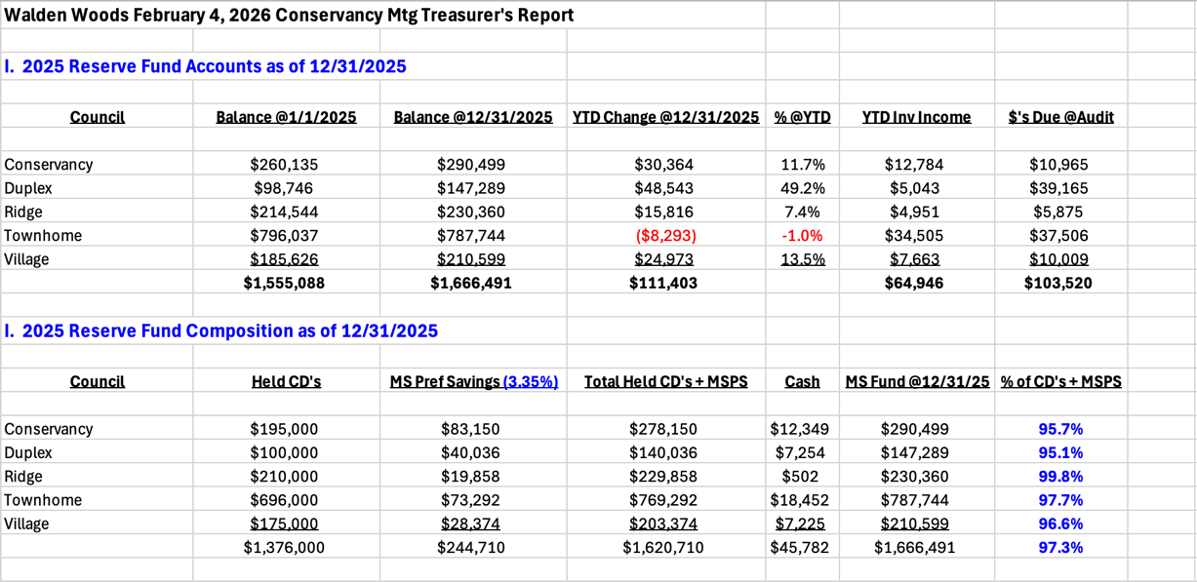

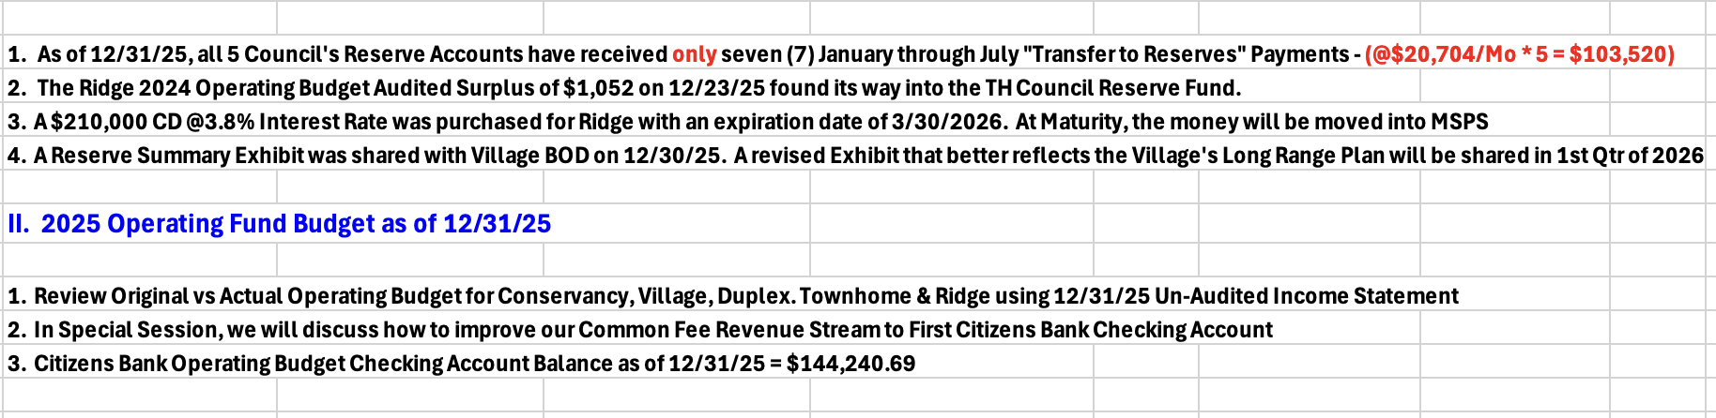

- PROPERTY MANAGER’S REPORT

  - Summary of Property Manager on-site activity:
Property Manager’s Report is on page 14 of the BOD Package.

Snow is the biggest issue at this time. Chris has been getting positive feedback on Butler’s handling of the snow.

A question was raised regarding cars in parking spaces. If someone gets hurt because snow was not fully removed, who covers the claim if one is filed? The Conservancy would cover it under the Community’s Umbrella Coverage.

There was notice of a truck parked on Last Leaf. It is being taken care of.

  - AAI status:
Two AAIs have closed since the last meeting. Two new AAIs have been received and currently there are 15 open AAIs.

  - Delinquent fees:
There are 6 units in Collections and more on the way. As of December 31, 2025, there is a total of $31,000 owed to the Association. Of that $31,000, $21,000 is Association fees and about $9,000 are fines and late fees.

- UNIT OWNERS’ FORUM – Unit Owners were given the opportunity to address the Board with thoughts and concerns.

- UNFINISHED BUSINESS:

Solar Shingles
The CT State Law regarding Solar panels in Communities in now in effect so the Board can now legally “Opt-Out.” If the Board decides to Opt-Out, the Attorney will bring the forms to the Town and file it. Once that is complete, then it’s brought to the Board to develop rules within the Community.

Brian motioned to Opt-Out of the language developed by the State of CT and follow the Attorney’s advice to generate our own rules. Louis seconded the motion. All were in favor. No one opposed.

Chris will send out an email asking all Board members to respond again regarding their vote so the Board members who were not in attendance at this meeting can respond.

At the next BOD Meeting, the process will begin to develop rules for solar within the community. As solar continues to grow, new technology will be reviewed by Standards Committee. Chris will work with Roland on the language to be used.

Truck on Lochview
Truck on Lochview is still an issue. One of the trucks is gone but this issue was to be resolved, and all trucks gone by October 31, 2025. Brian motioned to uphold original letter and assign a fine of $25 per day per the Bi-laws. Dieter seconded the motion. Gordon opposed. Balance of Board was in favor. There will be a hearing at the next BOD Meeting.

- NEW BUSINESS
There was concern about ice dams in the Townhomes. Chris stated that there are some leaks and they are being addressed.

A question was raised regarding putting a dog park in the Community. A review of the questionnaire sent to the Community last year was reviewed and discussed. There were no recommendations for additional amenities. It was stated that there is a Dog Park at NW Park.

- COMMITTEE REPORTS:
Included in BOD Package

- EXECUTIVE SESSION:
An Executive Session was in place after the Board Meeting.

- NEXT BOARD MEETING:
February 25, 2026, at 6:30 PM.

- ADJOURNED:
Meeting was adjourned at 7:49 pm. John motioned to adjourn the Meeting. Gordon seconded the motion. All were in favor.

The Executive Session was called to order at 7:50 pm and adjourned at 9:01 pm.

Respectfully Submitted by,
Regina Sanchez

