WALDEN WOODS
BOARD OF DIRECTORS MEETING MINUTES

MEETING DATE: December 3, 2025

STATUS OF THESE MINUTES: Final

ATTENDANCE:

Directors in Attendance: Bocuzzi, Moffa, Holcomb, Devlin, Dostal, Jones, Yalamanchili, Henry, Laliberte, Coleman, Onessimo

Directors Absent: Robertson

Elite Property Management Representative: Chris Kohnle

- CALL TO ORDER:
Director John called the meeting to order at 6:33 PM.

- APPROVAL OF THE PRECEDING MINUTES: Minutes from the October 29, 2025, Board of Director’s Meeting were reviewed with no changes. John motioned to approve the Minutes and Fred seconded the motion. All were in favor and approved the October 29, 2025, Board of Director’s Meeting Minutes.

- FINANCIAL REPORT: Ken reviewed the Financials as of November 30, 2025, with the Board.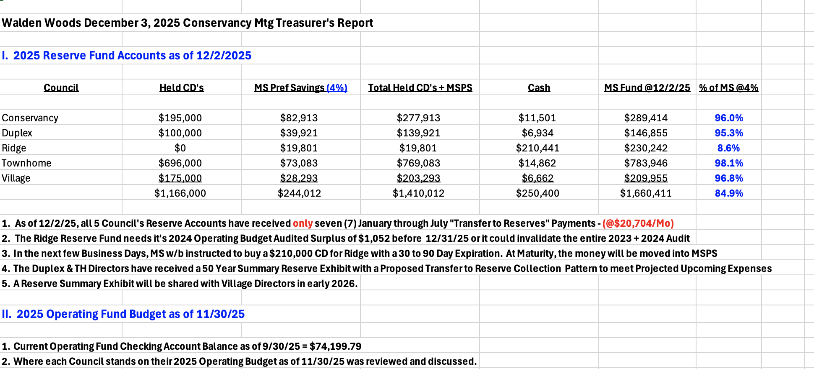

- PROPERTY MANAGER’S REPORT

  - Summary of Property Manager on-site activity:
On site reports start on page 17.

  - Scheduled Pending Services:
Butler is continuing to do fall clean-up. It will be completed after the snow melts. They will be cutting away grasses and perennials one more time. Final leaf pickup will be done as soon as all the Oak trees drop their leaves.

The nets on the Pickleball court will be removed by the end of this week. The fountain in the pond by the pool has been removed and stored for the season.

All irrigation has been winterized and the last winter fertilization has been spread.

  - AAI status:
Three AAIs have closed since the November 30, 2025, meeting. There are six new AAI requests and currently 14 AAIs are open.

  - Delinquent fees:
There are two units in Collections. As of November 30, 2025, there is a total of $37K owed to the Association. $8000K are fines and late fees.

- UNIT OWNERS’ FORUM – Unit Owners were given the opportunity to address the Board with thoughts and concerns.

- UNFINISHED BUSINESS:
Draft Budgets

The Board approved the 2026 Draft Budget. Increase in fees are as follows:

Conservancy – Increase $9.00 per unit owner per month
Village – Increase $6.00 per unit owner per month
Ridge – No increase
Duplex – Increase $25.00 per unit owner per month
Townhome – Increase $25.00 per unit owner per month

Gordon motioned to accept all budgets. John seconded the motion. All were in favor and no one opposed.

Voting for the 2026 Budget will now go to the Community via email and snail mail.

Solar Shingles
An email from a resident in the Villages was received. He responded to the letter he received regarding his AAI request to put Solar Shingles on his roof. A copy of the email can be found on page 53 of the BOD Package. Discussion about the new law regarding solar panels/shingles in Communities that will take effect January 26, 2026, will begin in 2026. Walden Woods will write guidelines for installation.

Unfinished Business

A letter to the homeowner who damaged the pickleball courts was sent out by the Attorney. They were given a time frame to respond.

A reminder was given to obtain a Usage Report from Butler regarding the irrigation system. Chris will work on obtaining it.

Page 31 of the BOD Package needs to be updated. Some of the information is outdated. The Garden Codes are incorrect. The new code is 2022.

There are no snow sticks in the upper village. Chris will investigate this issue

Food truck is still on Lochview. It was to be removed by October 31, 2025

- NEW BUSINESS

Jennifer has access to the new system (Enumerate) and can send messages herself. This is very helpful for her to send out announcements.

Holiday Party is this Saturday, November 6, 2025.

Pam Jones’ reported that the communications for scheduling Meeting House has been going well. See page 21 of the BOD Package for her comments.

Calendar on the Website and the Enumerate system are not matching. Chris will investigate this issue.

- COMMITTEE REPORTS:
Included in BOD Package

- EXECUTIVE SESSION:
None

- NEXT BOARD MEETING:
January 28, 2026, at 6:30 PM.

- ADJOURNED:
Meeting was adjourned at 8:02 pm. John motioned to adjourn the Meeting. Jennifer seconded the motion. All were in favor.

Respectfully Submitted by,
Regina Sanchez

