WALDEN WOODS
BOARD OF DIRECTORS MEETING MINUTES

MEETING DATE: April 29, 2026

STATUS OF THESE MINUTES: Final

ATTENDANCE:

Directors in Attendance: Bocuzzi, Coleman, Holcomb, Onessimo, Devlin, Dostal, Jones, Yalamanchili, Henry, Laliberte, Pearell

Directors Absent: Robertson

Elite Property Management Representative: Chris Kohnle

- CALL TO ORDER:
Director John called the meeting to order at 6:32 PM.

- APPROVAL OF THE PRECEDING MINUTES: Minutes from the March 25, 2026, Board of Director’s Meeting were reviewed and approved. John motioned to approve the Minutes and Russ seconded the motion. Gordon abstained and the balance of the Board were in favor of approval of the March 25, 2026, Board of Director’s Meeting Minutes. No one opposed.

- UNIT OWNERS’ FORUM – Unit Owners were given the opportunity to address the Board with thoughts and concerns.

- FINANCIAL REPORT: Ken reviewed the Financials as of March 31, 2026, with the Board.

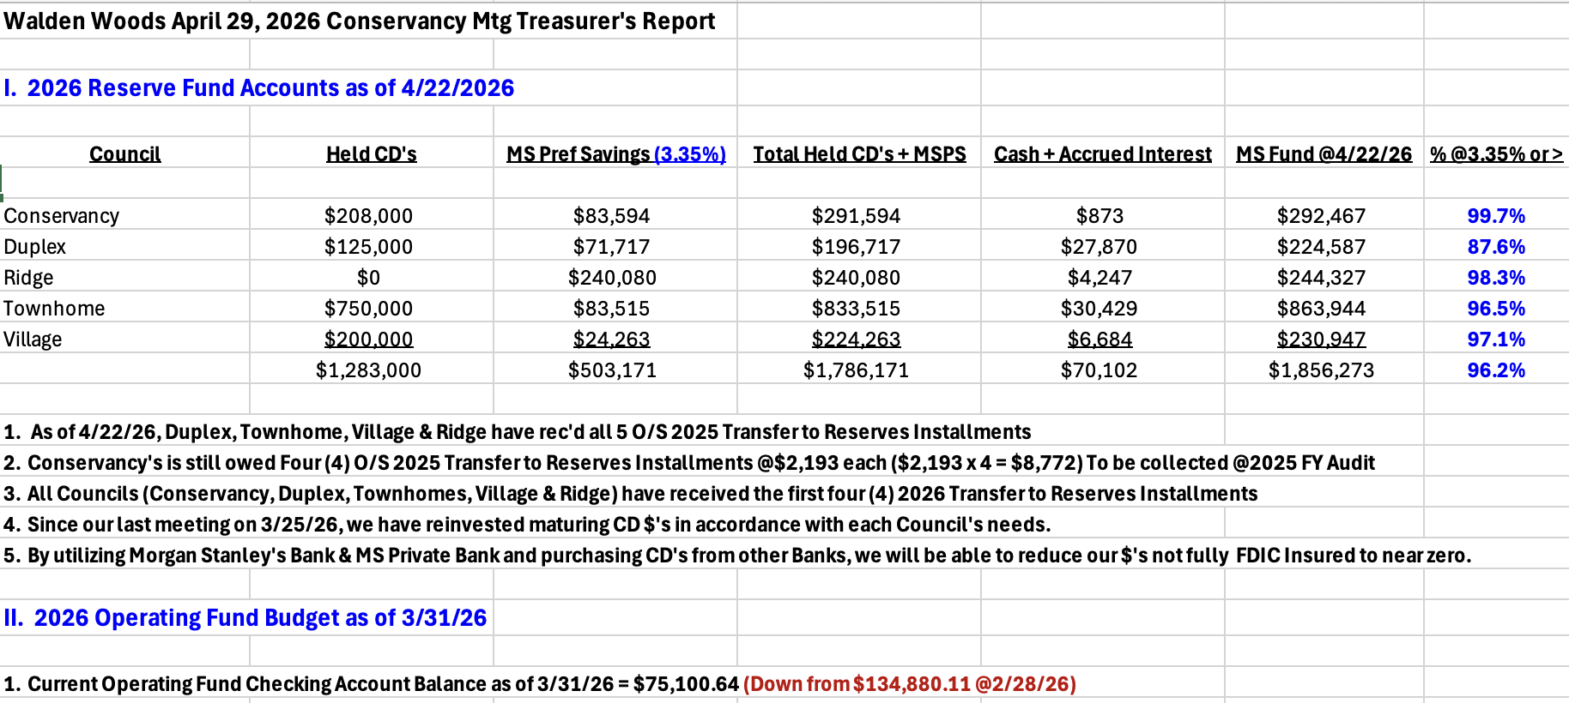
- PROPERTY MANAGER’S REPORT

  - Summary of Property Manager on-site activity:
Property Manager’s Report are on pages 15 & 16 and on-site activity reports begin on page 17 of the BOD Package.

  - Scheduled pending services
Concern was presented about the status of sidewalks and curbs throughout the community. Butler is using salt and was instructed not to. Repaired patches did hold but there is new damage. Chris will discuss this with Butler and inquire about the use of salt.

Damage to the Voltage boxes from plowing need attention as soon as possible

Bridge will be powered washed in the spring to remove any moss or mold.

Spring cleaning of the Community is still underway. The pool is up and running and will soon be cleaned. The pool will open Memorial Weekend.

Trees within the community will begin to be inspected

  - AAI status:
Five AAIs closed since the last meeting and eight new AAIs has been received. There are currently sixteen open AAIs.

  - Delinquent fees:
There are 6 units in Collections as of March 31, 2026. A total of $22,000 is owed to the Association. Of that $22,000, about $4,500 are fines and late fees.

- UNFINISHED BUSINESS:

- CONSERVANCY GOALS
Court Repairs – Damage to the Courts done by a resident will be discussed in the Executive Session. Hinding will hold the price from the prior proposal for warranty work and new cracks.

Camera for Courts – It was discussed that a camera needs to be considered for the courts based on the issue that the damage done by a resident was not on video and was only exposed from witnesses. Chris will pull the quote and put on the Agenda for next month’s Board Meeting.

Meeting House Patio Repairs – The price quoted last year for the replacement of broken bluestones and uneven areas will be held. The only price increase could be for the cost of additional bluestones if there are more broken bluestones since last year. John motioned to accept last year’s quote. Russ seconded the motion. Ken abstained. Balance of the Board were in favor.
Thoreau/Pierce Fence – Quote from Fence One to replace damaged sections of fence on Thoreau/Pierce. Price could increase slightly if the current parts they thought they could use need to be replaced. John motioned to accept the proposal of $1276.20 (and any minor adjustments). Louis seconded the motion. All were in favor.

- SOLAR PANEL RULES
Solar Panel Rules – the Paperwork is in process and being filed by the attorney. There was a slight delay as the form needed the Board Secretary’s signature. It was signed tonight and will be forwarded to the Attorney for final processing.

- COMMERCIAL VEHICLE STATUS
This will be discussed in the Executive Session.

- LAND SCAPING/SNOW REMOVAL
Landscaping and Snow Removal Contract – Chris opened discussion for the RFQ for next three years landscaping and snow removal contract. Gordon motioned that the back ballfield be treated. Brian seconded the motion. It was opened for discussion. Chris gave three options for this area. There is concern that treating it will be difficult to have it look like the balance of the community because there is no irrigation there. The three options were: 1. Do nothing
2. Fertilize entire area
3. Fertilize right of tennis courts to storage.
Chris will have a separate line item on the RFQ so the Board could have a clear understanding of the cost increase to the Community.

- NEW BUSINESS
- 8 On the Green Water Bill – Village Request
The water bill for this area gets split between the Village and Conservancy. Currently, there is not a fair split between November and April. The village does not use their irrigation system during that time, so no water is being used. Russ would like to make changes to the water bill as follows:
November – April – water paid by Conservancy
50/50 split of other fees
May – October -- 85% of water bill paid by Village
15% of water bill paid by Conservancy

Russ will write up details and give it to Chris to discuss at next Board Meeting,

- Meeting House Acoustic Panels
Tabled until next Board Meeting

- Pickle Ball Court Damage
Will be discussed during Executive Session

- Any New Business
It was requested that Chris get a price for a new sign at the entrance of the Community.

What is the status of WiFi for the pool. Chris will look into it.

When will the Green begin being treated for insects so it is ready for Movie nights? Chris will pull the contract he received and begin the process.

- COMMITTEE REPORTS:
Included in BOD Package

- EXECUTIVE SESSION:
None

- NEXT BOARD MEETING:
May 27, 2026, at 6:30 PM.

- ADJOURNED:
Meeting was adjourned at 8:22pm. John motioned to adjourn the Meeting. Jennifer seconded the motion. All were in favor.

The Executive Session was called to order at 8:22 pm and adjourned at 9:04pm.

Respectfully Submitted by,
Regina Sanchez

