Walden Woods News

March 2005

Inside this Issue

1 A Look at Elite 3 Board Resolution
2 Amendment Delayed 3 Pond Update
2 Standards Comm Report 3 Help Wanted
2 Joke of the Month 4 Meet Pat Tanner
2 Meeting House Rental 4 Dates to Remember

WALDEN WOODS NEWS is a monthly publication produced and distributed by homeowner volunteers for the edification and enjoyment of all Walden Woods homeowners. Questions, ideas and news contributions may be submitted to any member of the Communication Committee: Bob or Polly Ellis (688-5949), Ruth Johnson (688-5128), or Joe Sikora (219-0713).

A LOOK AT ELITE
common grounds and amenities
$60

(all pay)
2004

"Who'n the heck is Elite Management and why does Walden Woods need a Property Management Company anyway?"

Sound familiar? Unless you deal with Elite on a regular basis, it's a question that you and a few of your neighbors have probably asked yourselves on more than one occasion. You may be surprised at the number of services our Property Manager provides to keep Walden Woods running efficiently. Here's a summary:

BOOKEEPING:
Collect, Deposit and Track Monthly Association Fees needed for the upkeep and use of our community's facilities.
Authenticate, Pay and Track Expenses, extending the type of each expense for accurate budget tracking and identification of potential shortages.

Reconcile Bank Statement and Prepare Monthly Financial Statement showing all account balances, revenues and expenses with a monthly and year-to-date comparison to the budget.
Prepare Annual Operating Budget using the current year's expense data and known planned expense-incurring activity; also prepare line item explanations.

COMMUNICATION:
Prepare and Mail Board to Resident Correspondence, including delinquency letters and any necessary communication regarding bills, tenants or owner non-compliance with rules, etc. as the Board directs.
Respond to Homeowner Questions, Complaints and Concerns.

PROPERTY MANAGEMENT:
Perform Weekly Inspection of Property, including a review of contractor work and follow up on issues raised by the Board or homeowners.

continued on page 2

In case you haven't been able to attend recent Board of Director Meetings where they announce these sorts of things, our new Property Manager representatives are Frank Goeckler (frankgoekler@snet.net) and Quentin Hennessey (qhennessey@snet.net). Both can be reached at Elite Management (1-888-666-8300).

HAVE MEETING HOUSE,
WILL RENT

Charming Ambiance
Holds up to 60 People

Business Luncheons or Conferences
Banquets
Retreats
Seminars
Private Parties
Wedding Receptions
Showers

Whatever

Contact Bette Harner
688-4886 or
betteandkerm@aol.com

wine and beer permitted, catering optional
for:
A LOOK AT ELITE (cont'd)

Perform Annual "Walkaround" and Develop a Long Term Maintenance Plan with Board representatives to identify all items needing attention; also make capital expenditure recommendations for budget consideration.
Coordinate Competitive Bidding when the need arises for contract work or capital expenditure - either on a continual or specific need basis.
Prepare a Calendar for Re-Occurring Events such as tax return filing, snow removal bid preparation, gutter cleaning, etc.
Whew! And now you know why we need a Property Manager. ♣

Tennis Court Amendment Delayed

Promises, promises. As reported here last month, all homeowners were to be contacted to approve a proposed amendment to the declaration that would allow Culbro to build one additional tennis court on the new Parcel C recreation area rather than the three courts specified in the current declaration. The solicitation of your approval was unexpectedly delayed last month while lawyers hashed out the wording of the proposed amendment.

For those of you who have been waiting on your doorstep, we apologize. You will be contacted in the VERY near future and your approval is no less important this month. The elimination of two tennis courts will still add $41,000 to the Conservancy's reserves and generate anticipated savings in future maintenance costs.

Standards Committee Report

The following requests for additions, alterations or improvements were approved last month:

- Joe Palladino at 134 Primrose Lane received an OK to install a dryer vent on the front of his unit and to install a motion-activated spotlight on the rear of his unit for security illumination. The latter was approved on condition the light be recessed to illuminate only the intended areas and minimize any glare that may affect neighboring units.

- The Committee also approved a re-roofing request from Jim Curtis at 143 Pierce Blvd. and approved the proposed design and construction of the new Lot Home at 70 Lockview Drive, to be occupied by Mr. Ackley Beaumont.

JOKE OF THE MONTH

A man was driving down a quiet country lane when a rooster strayed onto the road.

Whack! The rooster disappeared under the car in a cloud of feathers. Shaken, the man pulled over at the farmhouse and rang the doorbell. A farmer appeared.

The man, somewhat shaken, said "I think I killed your rooster, please allow me to replace him."

"Suit yourself," the farmer replied, "the hens are 'round the back."
♣


"No winter lasts forever; no spring skips its turn."
- Hal Borland, Am Author

oh yeah?

Board of Directors Resolution

While the transition to a homeowner-controlled Association has gone very smoothly, thanks to a knowledgeable and effective Board of Directors supported by an enthusiastic number of committees and a capable Project Manager, we are still learning. One of the procedural requirements recently discovered is that all homeowners should be notified of all resolutions passed by the Board. Since this newsletter is distributed to all homeowners, it will be the vehicle used for all such notifications.

"WHEREAS, in accordance with Section 2.11 of the Declaration which requires that the Standards Committee consist of members appointed by resolution of the Executive Board, and one member by the Declarant,
NOW THEREFORE BE IT RESOLVED that the Standards Committee consist of the following members and such additional members as may from time to time be appointed by the Board, all members to serve for a term coincident with the terms of Board members and until successor members shall have been appointed by a subsequently elected Board:
Richard Ericson, John Webber, Ruth Johnson, Stanley Miller, Esther Miller, Gail Twarkins.
Be it further resolved, that the Board solicits the application for appointment to membership from Walden Woods homeowners in Councils not currently represented or underrepresented in the aforementioned list, and solicits the appointment of a Standards Committee member from CWD, LLC."

The following resolution, passed by the Board in December, relates to the makeup of the Standards Committee:

POND UPDATE

Our Environmental Committee (Lynne Gillette and Warren Johnson) recently met with a representative of the Country Walk developer (CWD, LLC also known as Garden Homes) and its project engineer to
discuss plans for cleaning up Walden Pond. CWD agreed to have the existing sediment at the discharge drain northeast of the dam removed at their expense. It was also agreed that some dredging is probably needed and CWD directed the project engineer to conduct a study on the extent, feasibility and cost of the dredging.

As previously reported in this newsletter, vortex units will be installed at "the earliest possible time in the construction schedule" to also help improve the water quality. The committee is also working with the Connecticut Department of Environmental Protection and the Windsor Environmental Officer to have the abutting industrial owners improve the drainage from their properties into the pond.

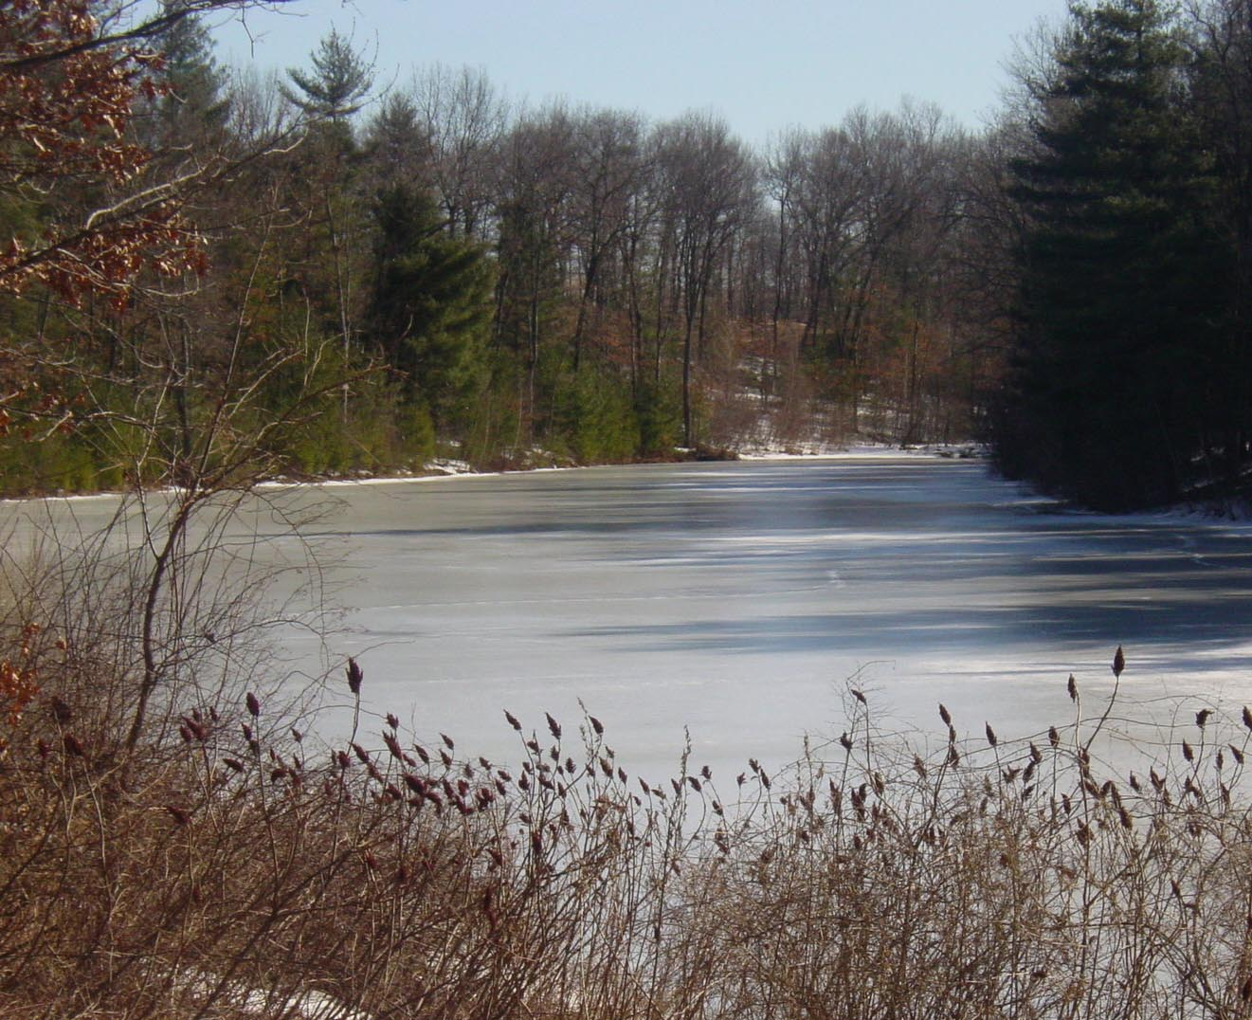
STILL WANTED

C'mon people. We need somebody to step up and volunteer just a little time and effort to serve as Association Treasurer and member of the Board of Directors. All you need is an interest in finance, an aptitude for figures and a willingness to help keep your community a nice place to live.

If you're interested, or if you know someone who might be, contact Raj Barman (593-9971) or Joe Sikora (219-0713).

MEET PAT TANNER

In Walden Woods, she's known as Pat Tanner, laid back, affable, INDEPENDENT (some would say stubborn), bright, and creative. At St. Mary's Hospital in Waterbury, where she works, she's known as "The Director." Nobody moves at St. Mary's without Pat telling them when to move, where to move, how to get there, and, if needed, who's going to help them. And in most cases, when they get there, they'll be in a room decorated by Pat.

In her official capacity as Director of the Service Response Center, Pat utilizes a computerized logistical and tracking system to assign, coordinate and verify completion of all services within the 320 (licensed) bed facility including patient transports. That includes everything from cleaning up spills in an elevator to tracking bed utilization, a potentially logistical nightmare. The latter task involves matching each patient's needs and compatibility with the beds available on an on-going basis and determining where and how each patient can be transported effectively to receive the timely medical care needed while at the hospital.

As if that's not enough responsibility, she's also in charge of space planning. Every time an individual or an entire department needs to re-locate, Pat determines the most effective use of the space to be occupied and

designs the appropriate layout of furniture, equipment and people. Her most enjoyable task, however, is designing the interior of the hospital when she can use her love and aptitude for decorating. She is currently working with outside consultants to develop a "way finding" system of easy-to-understand visual (as opposed to narrative) signs that will lead visitors from the highway all the way to their specific destination inside the hospital.

Born and raised in Troy, New York, Pat attended Cobleskill and Buffalo State Colleges to receive her degrees in Nutrition and Food Service Management. Hmmm? No, no, she's not responsible for the hospital's cafeteria food. She does, however, have a fondness for improv (no recipes) cooking and often uses her experience and education in the culinary arts
to entertain friends and family, recently hosting and cooking for a party of 40 people.

If she's not in the kitchen, Pat can be found either in her garden or on a local golf course. An outstanding multi-sport athlete in high school and college, she has finally succumbed to the AARP-eligible syndrome and now restricts her athletic interests to being a soccer spectator and an avid weekend golfer.

Moving to her Knollwood North home in 1998, she deservedly takes some pride in the independent, self-reliant lifestyle she's established. Although the 45 minute commute to Waterbury adds some extra length to her workday (often 12 hours +), Pat "enjoys her life in Walden Woods too much to consider moving." All her friends here would say that's definitely our gain and Waterbury's loss.

DATES TO REMEMBER
(All events at the Meeting House)

March 20th - Easter Egg Hunt, 2-4 PM (call Dick Armstrong @ 285-0803)

March 30th - Board of Directors Meeting @ 7:30 PM

April 1st - Game Night @ 7:30 PM (call Dick Armstrong @ 285-0803)

Note: Your Recreational and Social Committee has a great line-up of activities for the 2005 year. Some will require small cover charges to help with the expenses, some will not. Much time has been spent planning activities that take the entire community into consideration. Look for the announcement(s) in upcoming newsletters and please join your neighbors in supporting the events.
Next Event: Kentucky Derby Party - look for details in the April edition of the Walden Woods News.

NEXT BOARD OF DIRECTORS MEETING
Wednesday, January 26th @7:30

