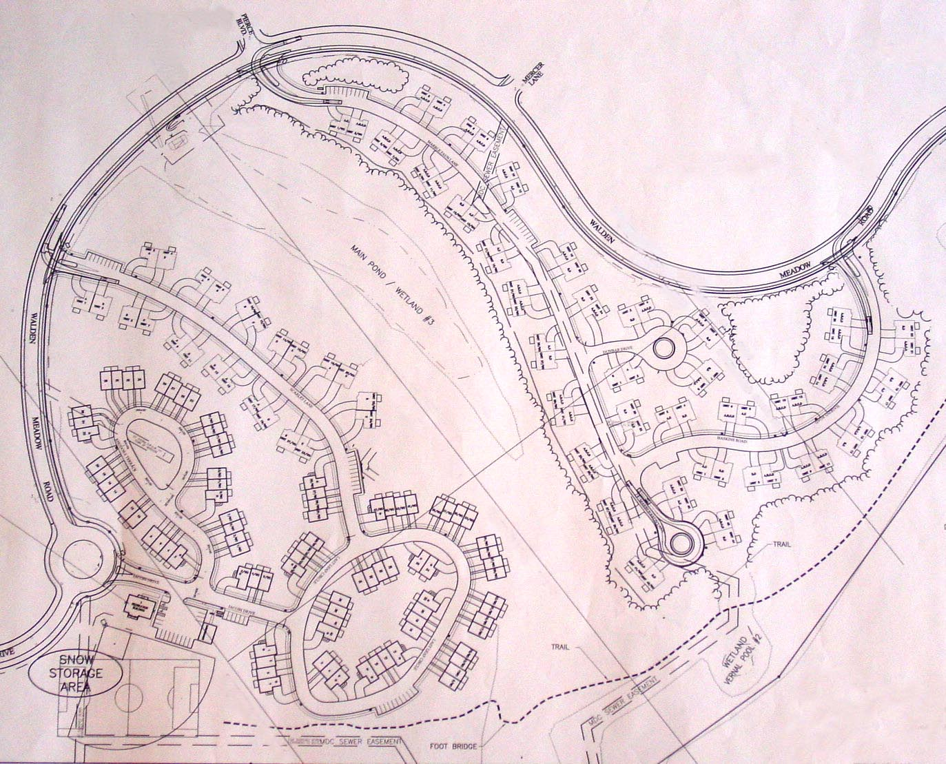
MARBLE FAUN LANE

Walden Meadow Road
BufferTrail
(to be built)
Johnson Trail Entrance

