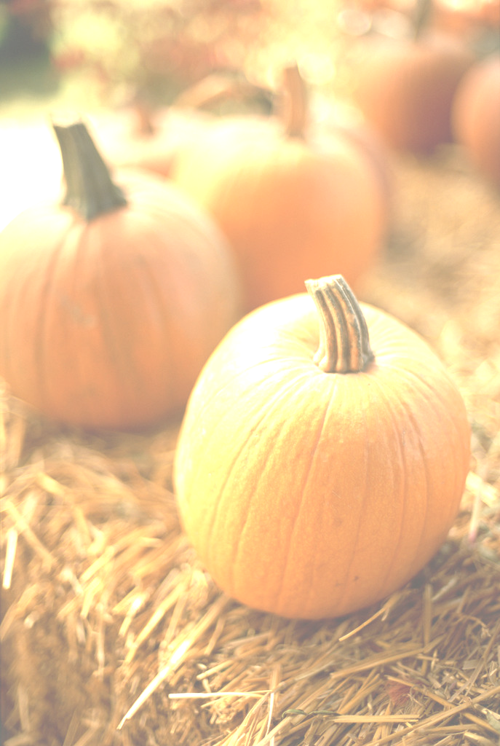
WALDEN WOODS
OKTOBERFEST
October 18, 2008 - Save the Date!
The Recreation and Social Committee is planning our first Oktoberfest! You can contribute to the fun by signing up for these events:
- Baking Contest – We know you have that special recipe that makes you a stand out. Ribbons will be awarded for the most delectable entries. Contact Joyce or Dick Armstrong for details @R_Armstrong@comcast.net
- Scarecrow Contest – We’d love to see your rendition of that guardian of the cornfield. Make it funny, sad, male or female, traditional or “out there”. This is a great project for everyone! Ribbons for 1^{st,} 2nd and 3rd place will be awarded. Contact Shiv @ shivrajv@yahoo.com
- Craft Fair - We know there are many talented people in Walden Woods. Display and sell your homemade crafts and goods at the Oktoberfest. Halloween, Thanksgiving, and the December Holiday Season are on the way! Contact: Barb @ bdjf@comcast.net OR Diane @ drewdgd@comcast.net
- Halloween Costume Contest – A parade around the Green of costumed fun-lovers from children to adults and yes, even pets. Judges will award prizes for the most original costumes.
- We’re looking for entertainers to perform their talents. Do you sing, play an instrument, dance, do magic or have an act that will amuse or entertain? Individuals and groups welcome. We’d love to see you! Contact: Dianne or John @dlparkny@aol.com

Enter as many events as you want! The more the merrier! Let’s make this a great event!
Don’t forget: There will also be food, games, face painting, pumpkin painting and more surprises. Details to come!

