WALDEN WOODS
KENTUCKY DERBY PARTY
May 6, 2006
2:30 – 6:30 pm at the MEETING HOUSE

Watch the most exciting two minutes in Sports projected onto a large Screen with Dolby Sound

Hat Parade
The second most entertaining parade on the first Saturday in May, next to the Kentucky Derby "post parade", is the parade of hats on display at Churchill Downs. From the fantastic to the sublime, there are no rules or limits.
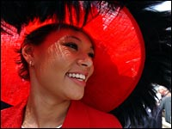
In the Clubhouse and Paddock, women of grace and taste sport classy, fashionable styles. And here at Walden Woods the tradition continues. Wear a Hat and enter the Parade-Prizes will be awarded!

Mint Juleps
The Mint Julep has been the traditional beverage of Churchill Downs® and the Kentucky Derby® for nearly a century. Each year, almost 120,000 Early Times Mint Juleps are served over the two-day period of the Kentucky Oaks® and Kentucky Derby®. A feat that requires over 10,000 bottles of Mint Julep Ready-to-Serve Cocktail, 1,000 pounds of freshly harvested mint and 60,000 pounds of ice. Come Lift a Mint Julep With Your Friends and Neighbors
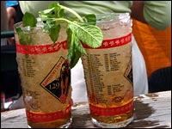

Southern Food Specialties

Tickets are $20.00 per Person and include all Food and Drinks as well as the chance to put a wager on your favorite.

Contact : Jack Keenan 687-1734 or john_keenan@hsb.com

