

Inside this Issue

1 Special Homeowner Meeting 3 Meet the Lennons
1 Website Available 3 We Have a Treasurer
2 Missing Eggs Found 4 Dates to Remember
2 Earth Day Cleanup 4 Joke of the Month
2 Landscape Report 4 Standards Committee Report

WALDEN WOODS NEWS is a monthly publication produced and distributed by homeowner volunteers for the edification and enjoyment of all Walden Woods homeowners. Questions, ideas and news contributions may be submitted to any member of the Communication Committee: Bob or Polly Ellis (688-5949), Ruth Johnson (688-5128), or Joe Sikora (219-0713).

Walden Woods News

April 2005

Special Homeowner Meeting
at the Meeting House
Wednesday, April 13th at 7:00 PM

As announced in the recent Elite Management letter to your household, there's going to be a special meeting of homeowners regarding an amendment to the Declaration. The purpose of the amendment is to reduce the number of tennis courts that the developer is currently required to build. If you have not yet been contacted by one of your neighbors to sign the amendment, PLEASE come to the meeting. Joe Sikora, our Board of Directors President, will be there to answer any questions you may have and to ask you to sign the amendment.

Basically, it comes down to whether you want three additional tennis courts or one additional court plus $41,000 that will be used to reduce the need to increase your association fee next year. A side benefit would be the future savings in expenses required to maintain what the vast majority of homeowners agree would be a surplus of tennis courts.
Website Available

The new Walden Woods website is now available for homeowners having access to the Internet.
www.waldenwoodsct.com

To pass the amendment, we need 80% of all homeowners to sign it. With an unknown number

of homeowners still away on their winter hiatus, we can't afford to have apathetic homeowners decide this issue. PLEASE BE THERE, listen to Joe, then make up your mind to sign or not sign the amendment. ♦

OR

MISSING EGGS FOUND !!

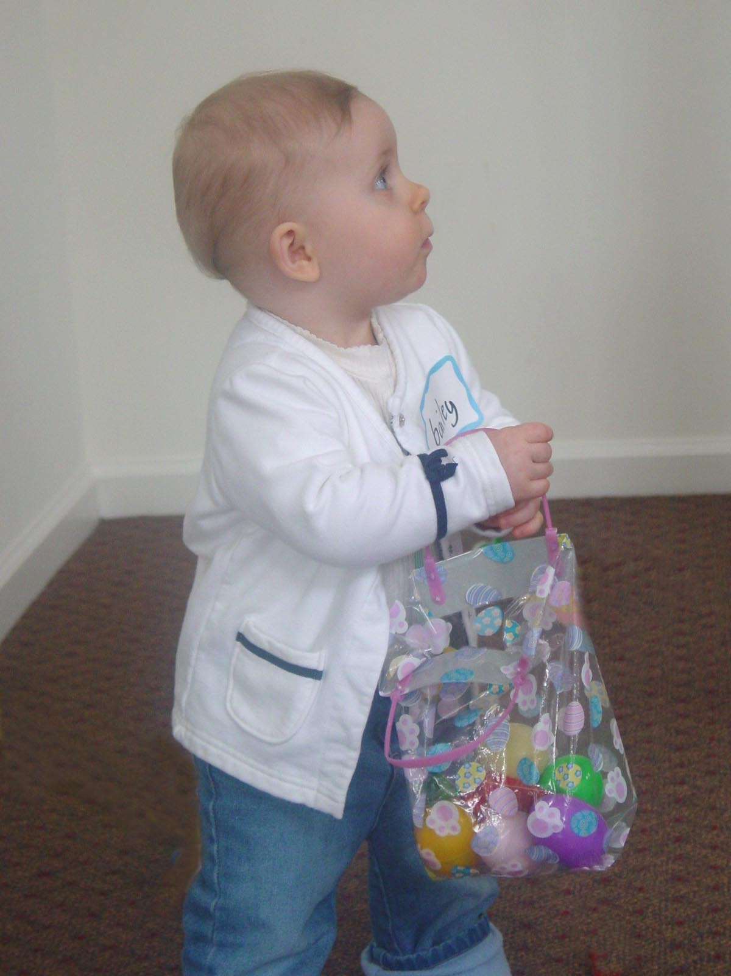
Miraculously, all the eggs were found at the first Walden Woods Spring Social and Egg Hunt party arranged by the Recreation and Social Committee. More than 20 children showed up with their Walden Woods parents or grandparents to enjoy two hours of egg hunting, game playing and "tattooing" at the Meeting House party held on March 20th. Sub-Committee members Dick and Joyce Armstrong, Jackie and Jan Moller, Pamela Jones and Johanna Dunlavey deserve a lot of credit for their hard work and contributions for what may become an annual event. ♦

Landscape Report


The Landscape Committee has gotten an early start this spring season. It has already met with our landscape contractor, Mike Russo, to discuss possible special projects to enhance the appearance of our community. A prioritized list will be submitted to the Conservancy's Board of Directors and whatever is approved will be paid for out of the Reserve budget.

Also, some good news for all of us who had to suffer through another long winter and are now looking at its ugly remnants. Spring clean up has begun. Progress is going to depend upon the weather of course, but our landscaping contract states that it must be completed by the end of April. This includes the removal of sand from the roads and walkways.

However, those roads plowed and sanded by the Town are cleaned up at their discretion. Last year, we were first on their schedule, this year the southern section of Windsor (Wilson) is first. ♦

"I am extraordinarily patient, provided I get my own way in the end." - Margaret Thatcher

VOLUNTEERS NEEDED

Walden Woods is going to participate in a cleanup campaign in conjunction with the town of Windsor and its first-time celebration of Earth Day on Friday, April 22nd. Our efforts will be focused on picking up trash and debris along Walden Meadow Road and the area adjoining Walden Pond that will soon become the site of our new hiking trail. Volunteers will be meeting in front of the Meeting House at 10AM and again at 1:00PM for two separate two-hour sessions. The town is providing trash bags and gloves to assist in the clean up and will provide a vehicle to pick up the bags afterward.

If you and/or your children would like to participate in one or both cleanup sessions, please call Joe Sikora, 219-0713. This is a great opportunity to make a direct contribution toward making Walden Woods a nicer place to live. ♦

MEET THE LENNONS

Editors Note: This profile of two of our neighbors contains some personal information of a type not normally made public, especially in this newsletter. Readers should understand that the subjects not only did not object to the revelation, they encouraged it.

They don't look 18. Bob and Malvi Lennon are actually 56 and 47 respectively, but they both insist their lives only began 18 years ago. Not so coincidentally, that's when they met - outside a Tampa Florida office building where they both worked. That's the same year they got married and that's the year they began sharing their lives together with their five children from previous marriages.

It's also the year when they developed a mutual support system that allowed them to live their lives free of the alcohol that had been threatening their self respect and their quality of life, if not their very lives, for a number of years. "If it wasn't for Malvi, I would be dead by now" confessed Bob. "She gave me hope by insisting my life was worth saving and that the only way it could be saved was with some outside help. When she became involved in my involvement with AA, she became aware that she not only shared my love, she shared my problem. We were able to support each other in our recovery efforts and our lives have been blessed ever since."


Bob and Malvi were so successful in re-building their lives, they decided to help other couples by getting involved in Retrouvaille (Rediscovery), an international program designed along the Marriage Encounter format but with more depth and follow up activities to help couples having relationship problems. When they moved to Connecticut in 1994, they established the Connecticut chapter of the program and, using hotel banquet rooms and church basements, coordinated meetings and led groups of couples through the sharing-of-feelings concept for 10 years.

Bob, originally from Providence and now retired from General Dynamics after 35 years as a pipe designer, is now content with the quiet life in Walden Woods. Moving here with Malvi in November from Old Saybrook, he now spends his time remodeling the downstairs of his Pierce Blvd. home, working on his computer (self-taught) and spoiling the family pet, a "mutt" named Cinnamon.

Malvi, an insurance adjuster for IFG Insurance for most of her adult life and still working, came to America from Cuba when she was 10 years old. She remembers that when her father requested emigration from Cuba, he was laid off from his job and their bank account was frozen. Nobody would hire him and they had to survive on what her mother made baking and delivering pastries. After three years of waiting, government officials finally came to their home to announce their request had been approved, then told them to leave immediately - with the clothes on their backs as their only possessions. Finding work in New Jersey, the family eventually moved to Florida and the rest, as they say, is history.
WE HAVE A TREASURER !

Joe Paladino of 134 Primrose Lane has volunteered and been approved by the Board of Directors to assume the role of Conservancy Treasurer. With his background in finance and economics, Joe is well qualified for the position and brings the needed sense of commitment to the position. Thanks Joe for stepping forward when we needed you.

Thanks also to Joe's predecessor, Raj Barman. This community owes you a standing ovation for the level of conscientious service you performed as our first Treasurer and member of the Board, and we wish you the best of luck in your new business venture.

Bob and Malvi's family now includes four grandchildren and, interestingly, three of their children are pursuing careers as law enforcement officers. As with many grown families, theirs is scattered about and not surprisingly still keep in close touch to share what's going on in their lives. It's something they learned from their parents. ♦

DATES TO REMEMBER

Wednesday, April 13 @ 7 p.m. - Homeowners Meeting on Declaration Amendment
Wednesday, April 20 @ 7:30 p.m. - Board of Directors Meeting
Friday, April 22 @ 10 a.m. and 1 p.m. - Earth Day Cleanup (call Joe Sikora, 219-0713)
Friday, April 29 @ 7:30 p.m. - Game Night (call Dick Armstrong, 285-0803)
Monday, May 30 - Memorial Day Pool Party (details to be announced)
Note: The Kentucky Derby party planned for May 7th has been canceled for this year.
The Community Tag Sale planned for mid May has been postponed until September. Details will be published well in advance of the event to give everyone a chance to gather their valuable junk.

Joke of the Month

As they say on the Internet, this is a "true story."

Dave Gorman, who lives on Aster Place, was passing by the Country Walk construction site when he overheard one of the construction guys bragging that he could outdo anyone in a feat of strength. The guy started making fun of Dave, who is in his 60's and not quite the physical specimen of his younger days. Dave tried to ignore him, but when the taunting continued, he had had enough. '
Standards Committee Report

The Standards Committee approved a request from Bruno and Mary Ciraldi, 32 Knollwood North, to install a satellite dish (39-inch maximum) on the backside of their roof. The decision was made after the committee determined the dish would be unobtrusive and a poll of neighbors revealed no objections. ♦

'Why don't you put your money where your mouth is,'' Dave said. "I'll bet you ten bucks I can haul something in a wheelbarrow over to that trailer that you won't be able to wheel back.''

''You're on, old man,'' the braggart replied. ''Let's see what you got.''

Dave reached out and grabbed the wheelbarrow by the handles. Then, nodding to the young man, he said, ''All right. Get in.''

NEXT BOARD OF DIRECTORS MEETING
Wednesday, January 26th @7:30

