Village Council White Vinyl Fences 6/30/22 PJD

Budget usually calls for power washing the fences every three years. It is essential that Elite gets several quotes. Last time we washed the fences, prices varied by thousands of dollars.

Marco was low bidder last time and did a good job.

There are two different styles for our fences. The front fences along our roads, stone walls, entrances differ from out back fences that are attached to each unit.

Lower Village has 360 linear feet of front fence. Upper Village has 360 feet of front fence. So total is 720 linear feet in that front yard style..

Lower Village has 1600 linear feet of the backyard style of fence. Upper Village has 3000 linear feet of the backyard style. So total is 4600 linear feet in that backyard style. All 72 units have backyard fences.

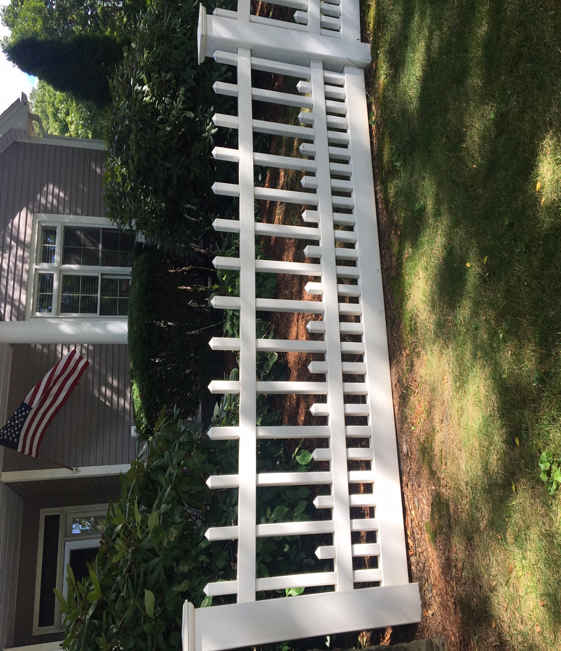
The caps on the front yard fence post are 7x7 (inches.) The posts themselves are 5x5. The bottom rail is 6x2. The mid and top rails are 3 ½ x 2. The smaller slats are 1 ½ x 1 ½ and are about 20 tall. The longer slats are the same width but are about 42 inches tall. The little caps on top of the slats are 1 ½ square. The total height of the fence is about 48 or 50 high.

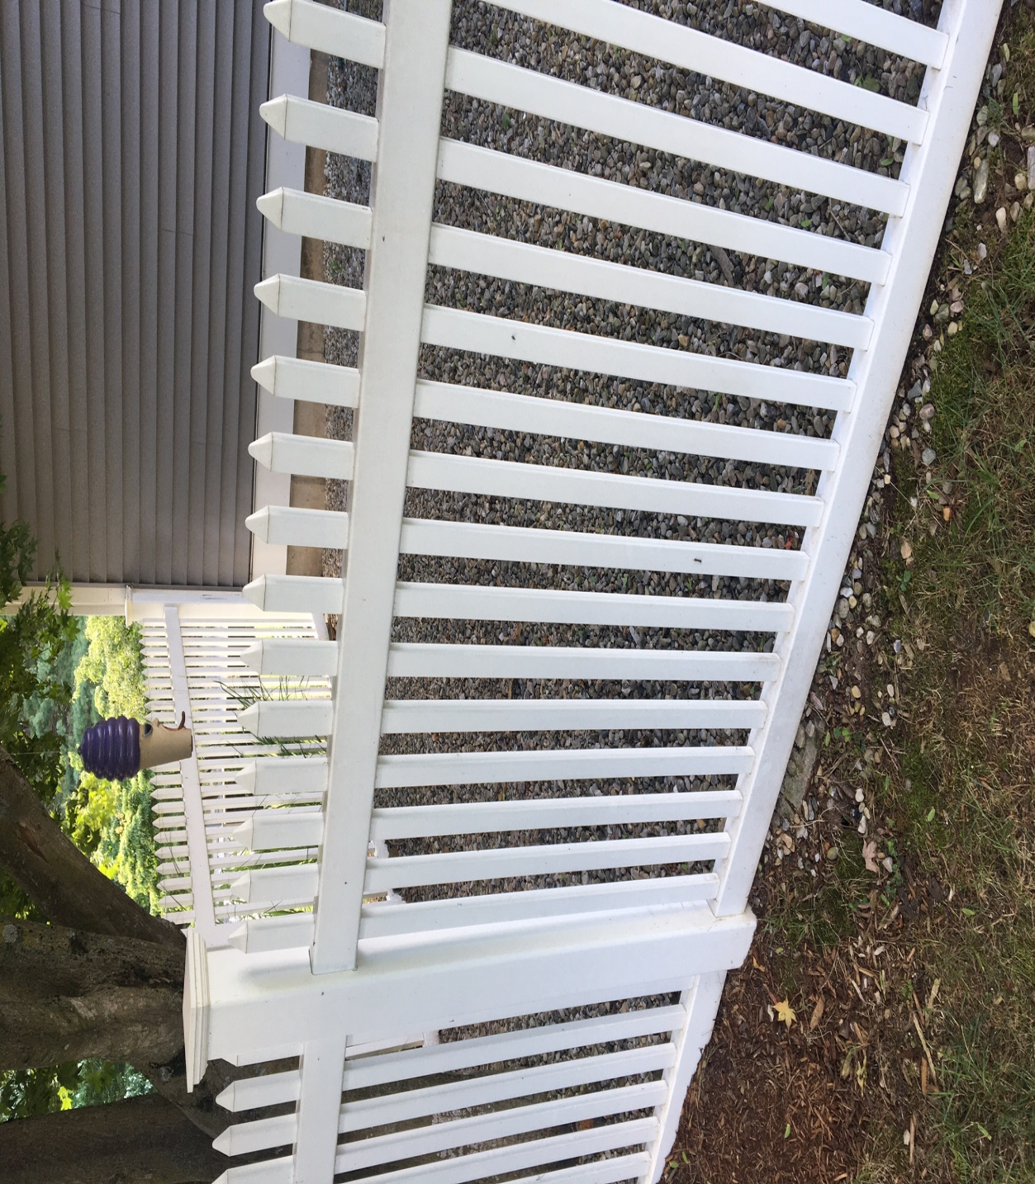

The back yard fences have post caps that are 5 ½ x 5 ½ on top of posts that are 4x4. The two rails are 3 ½ x 2. The slats are 1 ½ x ¾ and are generally 46 high. The little caps on top of the slats are 1 ½ by ¾
The biggest replacement item is the 1 ½ x ¾ caps on the back yard fences. 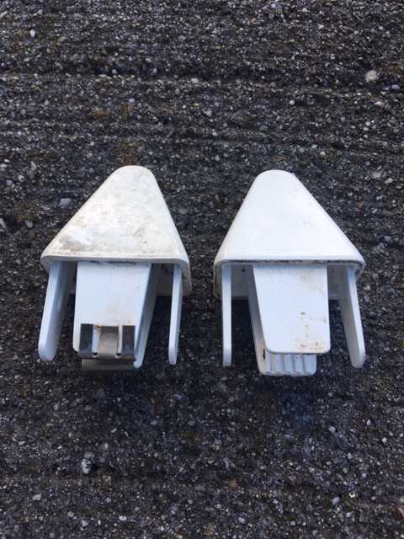
The one on the left has a little metal tab that holds the cap in place. The one on the right has two plastic tabs. Both will work. A drop of PVC glue helps both. The caps tend to come off during powerwashing.
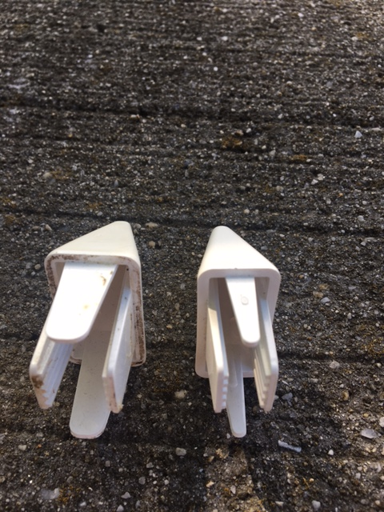
The one on the right does not work at all. You can see it has a much smaller tabs on one side. The outside dimensions are also smaller. These do not stay on.
The fences were installed by Hazen Construction, East Granby. There are some spare parts in the MH basement.

