Shrubs

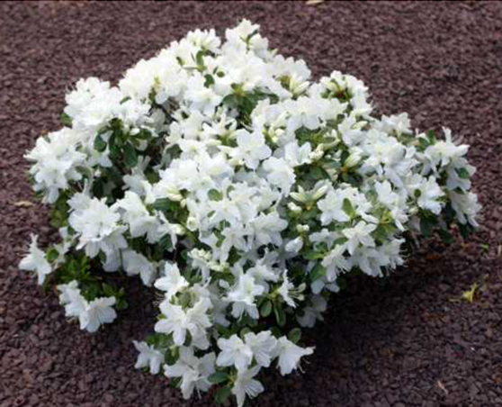
Delaware Valley White Azalea:

This Plant produces a dazzling display of lightly fragranced white bell shaped flowers and dark green, evergreen leaves. Bouquets of flowers are formed in tight clusters at the ends of each branch. The Delaware Valley Azalea is a bush that can reach 2-3 ft. high and wide.
(Soil Type Adaptable, Sunlight Partial, Drought Tolerance Good, Growth Rate Moderate)

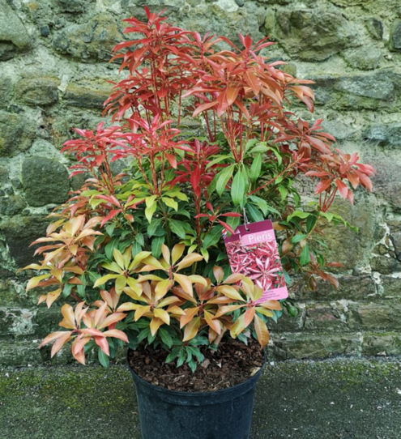
Mountain Fire Andromeda:

This plant is popular ornamental broadleaf evergreen shrub with delicate and showy chains of small white bell-shaped flowers and fiery red emerging foliage, extremely colorful in spring; performs best in moist, organic and acidic soils. The Mountain Fire is a bush that can reach 7-14 ft. high and 7 ft wide. (must be trimmed every year if near house)
(Soil Type Acidic, Sunlight Partial, Drought Tolerance Good, Growth Rate Moderate)

Sea Green Juniper:
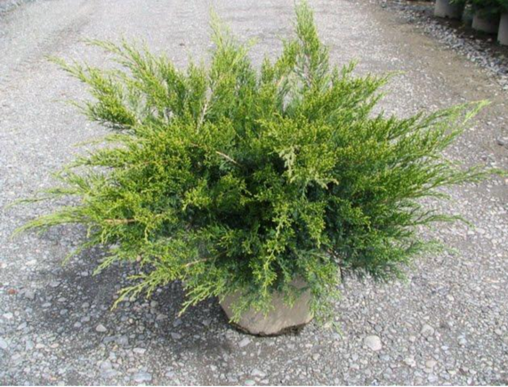
Sea Green Juniper is a compact shrub with a fountain-like, arching habit and soft foliage. It is a true evergreen, actually getting darker green in the deepest part of winter when it really stands out in your landscape. Mature Height 4 – 6 ft, requires annual pruning if near foundation.
(Soil Type Adaptable, Sunlight Partial, Drought Tolerance Good, Growth Rate Fast)

Little Missy Boxwood:
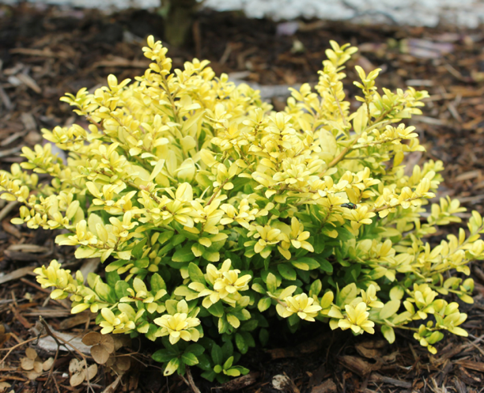
This broad-leaved evergreen has smaller leaves that grow tightly packed together. Often, new growth will flush chartreuse before settling into its deep green color. The plant's produces small yellow flowers. Mature Height 2 ft,
(Soil Type Adaptable, Sunlight Partial, Drought Tolerance Good, Growth Rate Slow)

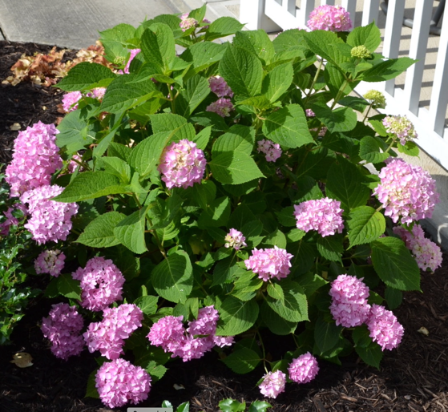
Endless Summer Hydrangea:
This plant comes in a number of colors. The plant produces flowers from June through September. Unlike many hydrangeas, it blooms on both old and new growth, which means it forms the flower buds for next year's blooms during the current year. Mature Height 3 – 5 ft. Prune in Spring only!!
(Soil Type Adaptable, Sunlight Partial, Drought Tolerance Good, Growth Rate Fast)

Inkberry, Ilex Glabra:
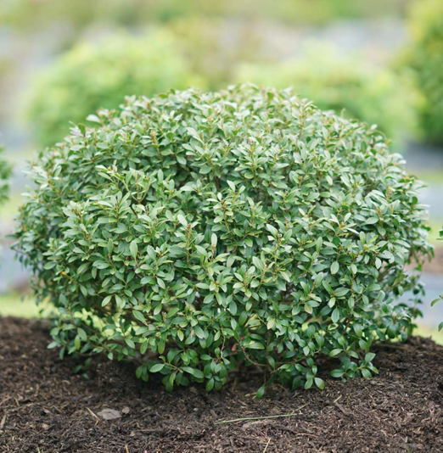
Inkberry is an upright, erect, rounded, much-branched shrub that becomes open with age Prune to shape in early spring just before new growth begins. Plants generally need minimal pruning unless used as a hedge . Mature Height 5 – 7 ft, requires annual pruning if near foundation.
(Soil Type Adaptable, Sunlight Partial, Drought Tolerance Good, Growth Rate Slow)

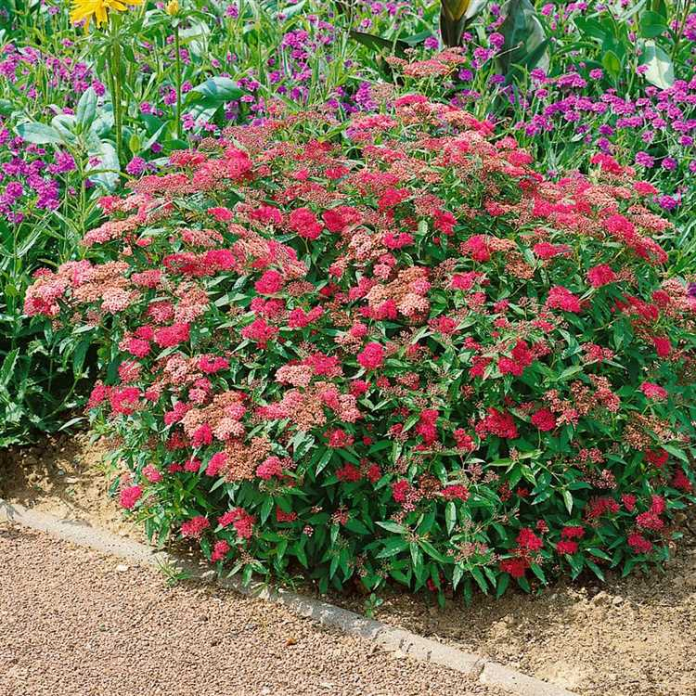
Bumalda Spiraea. Anthony-Waterer:
Flowering shrub that can grow to 2 or 3 feet tall and 3 to 5 feet wide. is a garden hybrid, the result of a cross between Spiraea albiflora and Spiraea japonica. Plant grows easily in average, medium moisture, well-drained soils in full sun. The plant displays white to deep pink flowers in flattened corymbs in an abundant bloom from late spring to mid-summer.
(Soil Type Adaptable, Sunlight Full, Drought Tolerance Good, Growth Rate Medium)

Clethra alnifolia Sixteen Candles, Summersweet

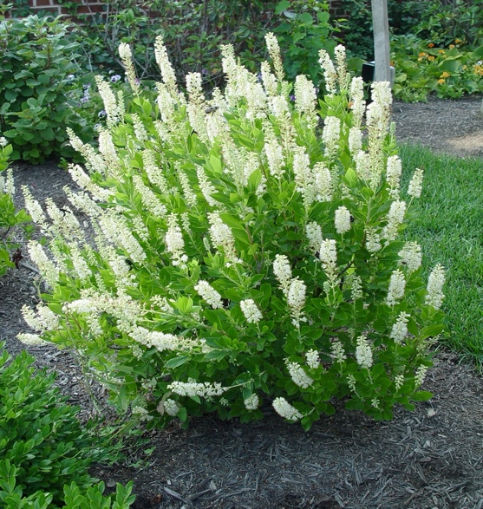
A profusion of upright fragrant white flower spikes attract butterflies. Dense, compact habit makes it good for small gardens. Effective in mass, mixed into perennial borders or along foundations. Grows well in wet areas. Deciduous. Mature Height 3 ft
(Soil Type Adaptable, Sunlight Full, Drought Tolerance Fair, Growth Rate Slow)

Ground Cover

Hosta
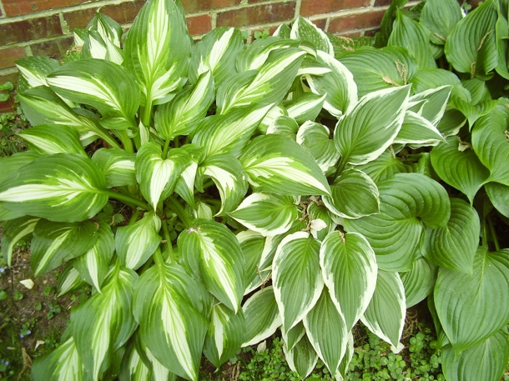
Hosta is a clump-forming plant that grows from rhizomatous roots. It produces blooms on long stalks that extend well above the clumping foliage in late spring or summer, but the foliage is the main attraction. Among the hundreds of hosta cultivars, there are fast-, medium-. and slow-growing varieties.

Ajuga:
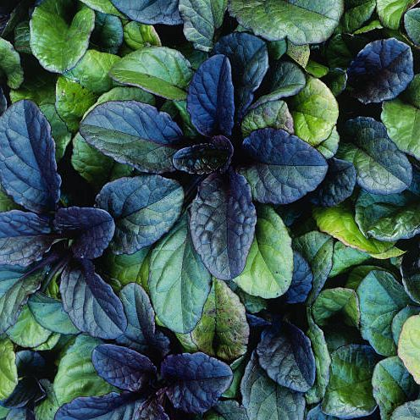
Glossy leaves in shades of deep green, bronze, and chocolate-brown make this perennial a great low-growing lawn alternative for almost any climate. In summer months, little spikes of blue, purple, pink or white flowers will appear. Ajuga spreads rapidly in varying conditions, tolerating shade or sun.

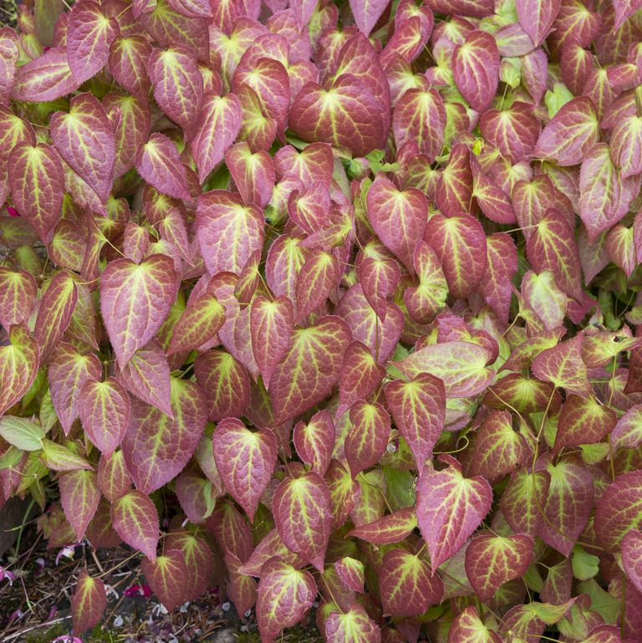
Epimedium: Bishop’s Cap

In early spring, flowers that look like fairy wings appear on this perennial, This plant can tolerate dry conditions once established. It's cold hardy and prefers part shade

Microbiota (Siberian Carpet).

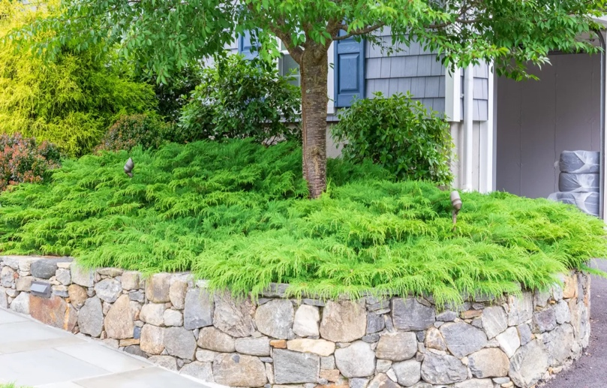
Microbiota is genus of evergreen coniferous shrub in the cypress family Cupressaceae,. is a prostrate shrub that grows from 1.0 ft –1.6 ft in height, and 6 ft –16 ft in spreading width. The foliage forms in flat sprays with scale-like leaves ¼” to 3/8 ” long. Microbiota is grown as an ornamental plant for use as evergreen groundcover in gardens and parks. It is valued for its drought tolerance and considerable cold temperature and winter season conditions tolerance

(Could use 2 more ground cover plants)

Trees:

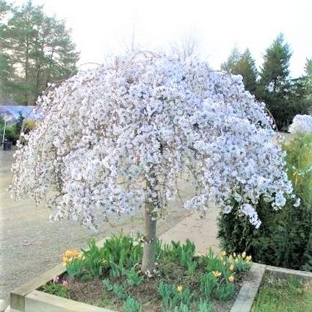
White Snow Fountains Weeping Cherry

Prunus x 'Snofozam'
This is an outstanding accent tree that will become a showpiece in your landscape. This tidy, compact ornamental features a classic weeping Cherry form - it's the perfect specimen plant.
Early in spring, you'll be thrilled to experience the stunning display of pure white blossoms that flower before the leaves appear. In the leaves of your flowering Cherry tree develop spectacular fall displays of orange and red.

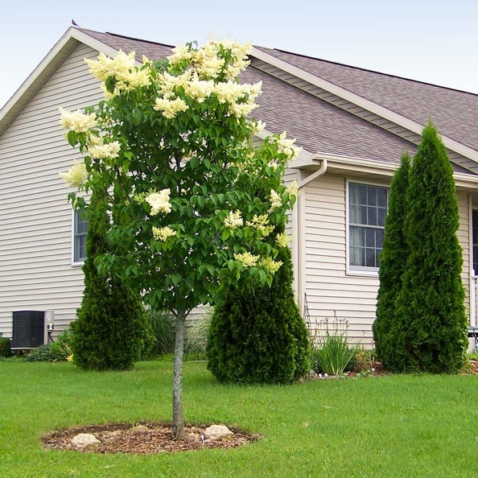
Ivory-Silk Lilac Tree
This plant grows much taller and wider than other Lilacs. It still has fragrant blooms, but in a Super-Size version. This is not the flowering shrub, but a small tree that bears huge, foot-long flower panicles in late June. Delicate, creamy white flower bunches perfume your entire garden in early summer with a fresh, sweet scent. After the blooms pass, you'll appreciate the refreshing shade from the large leaves. Through the summer, the Tree will be densely covered in beautiful, dark green leaves

October Glory Maple

or
Autumn Blaze Maple

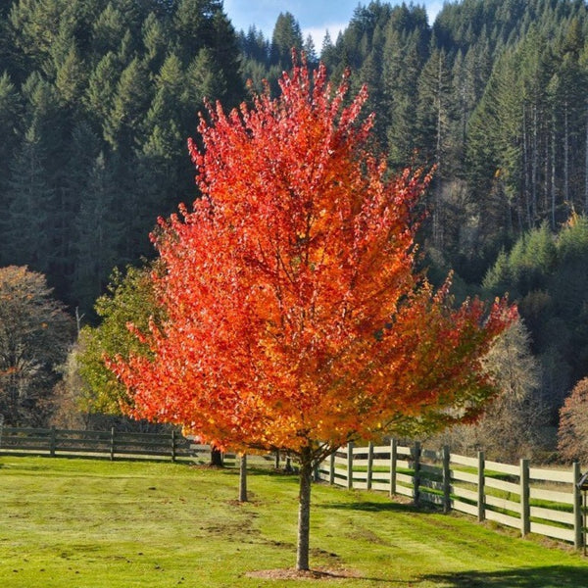
Very fast-growing Red Maples. These ever-popular maples should be considered as a beautiful shade tree addition to any yard. Glistening dark green leaves in spring, summer turn radiant red late fall and last several weeks. Showy red fruit attract many birds and other wildlife. Grows up to 3 feet a year to 30'-50' high with a 25'-35' spread. Tolerant of many soils, but prefers slightly acid and moist conditions. Plant in partial shade to full sun.

Cleveland Flowering Pear
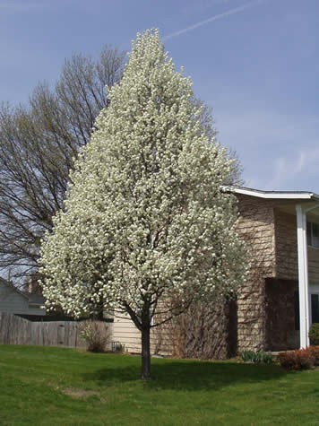
An upright, narrow pyramid shaped tree. Perfect for smaller yards where space is limited. This is a fantastic choice for a formal row of trees and also for screening out unwanted views. Abundantly produced white flowers in early spring. It has thick green shiny leaves in the summer that turn a spectacular array of orange to red in the fall. A very WATER THIRIFTY tree. Hardy to -30°F Maximum Elevation: 6,500 Feet

Thuja Green Giant
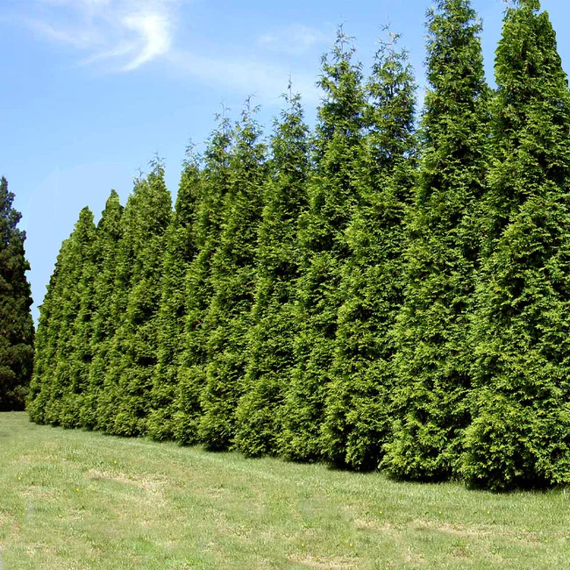
Arborvitae tgat: quickly gives you a lush, rich privacy screen. Cold hardy. Adaptable to a variety of soil conditions These trees will grow up to 3 to 5 feet each year. These plants delivers dark green foliage year-round. Arborvitaes blocks noise, neighbors and unsightly views while taking very little space. Are cheaper than a traditional fence.

